**Introduction**

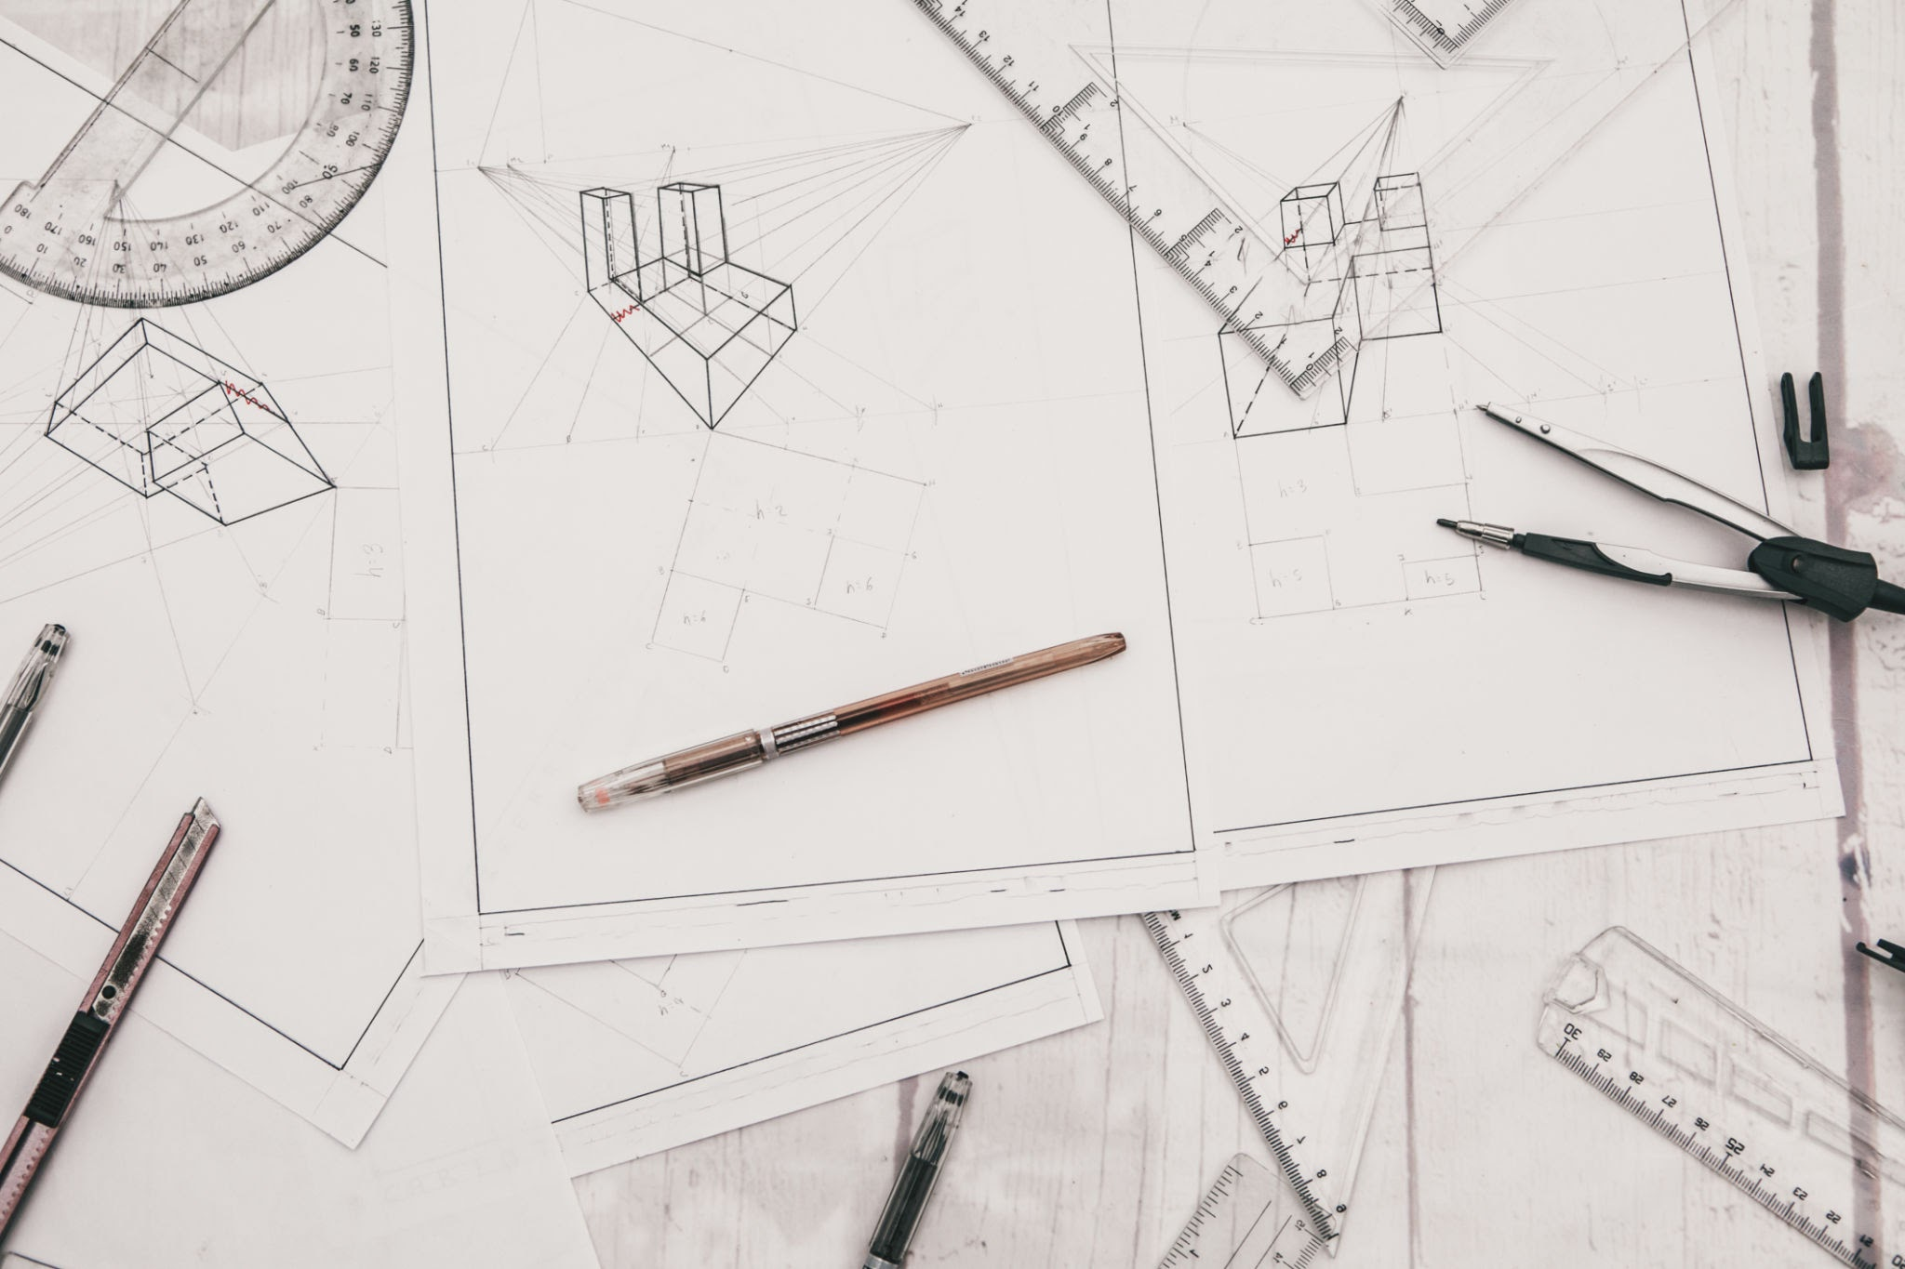

Twenitú Overview

This document provides a comprehensive overview of the operational framework across all departments within the company. The information is meticulously organized into distinct tabs, ensuring a user-friendly and clear structure for accessing specific departmental data.

The departmental breakdown includes:

## General Office Administration:

*This section details the overall functionality of the office environment, including logistical arrangements for supplies and equipment, maintenance schedules, communication protocols, and the effective management of essential administrative resources that support the entire organization.*

## Personnel Administration & Labor Relations:

*This tab encompasses all aspects related to human resource management, such as employee recruitment and onboarding, performance evaluations, training and development programs, benefits administration, employee relations guidelines, and the management of labor-related matters and legal compliance.*

## Design & Engineering:

*Here, you will find comprehensive specifications for all product designs, detailed developmental plans outlining project timelines and milestones, progress updates on ongoing engineering initiatives, technical documentation, and research and development activities within these critical departments.*

## Operations:

*This section offers in-depth insights into the day-to-day operational activities that drive the company's output, including core production processes, supply chain management, quality control measures, workflow optimization strategies, and established procedures that ensure efficiency and productivity.*

## Finance & Accounting:

*This tab houses crucial financial statements such as balance sheets and income statements, detailed budget allocations and tracking, comprehensive accounting records of all financial transactions, pertinent financial reports for analysis, and information related to auditing and tax compliance.*

## Legal:

*This section contains all relevant legal documentation, including contracts with vendors and clients, intellectual property filings, compliance reports, and information concerning legal affairs, regulatory requirements, and risk management strategies that protect the company's interests.*

## Business Planning and Sales Promotions:

*This area outlines strategic business plans with defined goals and objectives, in-depth market analyses identifying opportunities and competitive landscapes, the frameworks for various sales and promotional campaigns designed to drive revenue growth, and marketing strategies.*

## Management:

*This tab encompasses key managerial decisions related to strategic direction, organizational changes, and resource allocation, provides performance reports on overall company and departmental achievements, and clarifies the overarching organizational structure, including reporting hierarchies and responsibilities.*

Each tab within Project Twenitú is specifically designed to provide a thorough and easily navigable account of the distinct functions, responsibilities, and essential information pertinent to the respective department, fostering transparency, facilitating informed decision-making at all levels, and ultimately enhancing overall organizational efficiency and collaboration.

**06_Legal**

**Contract Proposal**

**This Agreement is made on June 10th, 2025**

**RE:** 900 Tri-State PKWY **Client:** Projecto Twenitu LLC Gurnee, IL 60031

**I. Scope of Work:** Prepare permit plans for the addition of a bathroom group in an existing open warehouse. Plans to include “permit set” architectural and plumbing plans as needed. Separation of spaces all other work to be done by others, Projecto Twenitú LLC is responsible for the permitting of new bathroom installation.

**II. Projecto Twenitú LLC Responsibilities:**

1. Field measuring and observation: Projecto Twenitú LLC (hereafter referred to as “Projecto Twenitú LLC”) shall come out to property to measure once agreement is reached. Owner is responsible for informing occupied units/areas that access is needed. Projecto Twenitú LLC is not responsible for spaces where access was not gained and all estimates/guesses for areas with no access are for presentation only. Projecto Twenitú LLC shall not do exploratory demolition to determine framing sizes, directions, or conditions of the existing structure. Projecto Twenitú LLC is not expected to remove attached covers, make holes, or perform tests that could damage an item or area being observed. If Projecto Twenitú LLC needs to come out again to measure from not having access to all required spaces an additional charge will apply at hourly rates.
2. Zoning analysis to determine allowed build conditions. Officials have final jurisdiction on all matters.
3. The Design Phase: consists of three Design Revisions. Design changes beyond this number will result in additional architectural fees at hourly rates.
4. Preparation of final design documents, in accordance with Owner’s response to preliminary design and scope.

**III. Payments and Compensation to Projecto Twenitú LLC:** **General Payment Schedule:** a. Retainer: An initial payment retainer of $2,400.00 shall be paid upon execution of this Agreement. b. Additional Payment: when floor plan is approved and ready to start MEP, $2,400.00 shall be paid. c. Additional Payment: When plans are ready and before city review, additional $2,400.00 shall be paid. d. Final Plans and Permits: When all plans are approved and permit is issued through DOB, final payment of $960.00 will now be due before any documents are released to owner. **Payments will total: $8,160.00** e. Additional Services: letters, addendums, changes, construction site visits, supplementary copies, and detailed construction cost estimating are billable expenses and due at the completion of the service. f. Structural engineering: no structural plans/calculations/reports are included. May be as additional services. 2. Projecto Twenitú LLC shall be compensated for reimbursable expenses plus 10%. 3. Construction site visits: site visits shall be billed at an hourly rate. 4. Revisions and Addendums requested after the approval of design or approved permit will be billed at the hourly rates. 5. Payments are due and payable upon owner’s receipt of Projecto Twenitú LLC invoice. 6. Payments shall be made payable to Projecto Twenitú LLC. Undisputed amounts unpaid (30) days after the invoice date shall bear interest from the date payments are due at a rate of (1.5%) per month. 7. This proposal shall be void after (3) months of the above contract date. Projecto Twenitú LLC fees listed in the proposal shall be valid for (9) months after the owner’s acceptance of this contract. Projecto Twenitú LLC fees may be increased if the services are required beyond (9) months.

**IV. Hourly Rates:** Architect/Engineer: $257.25/HR Project Manager/Expeditor: $173.25/HR Draftsman: $120.75/HR Administrative: $78.75/HR

**V. Owner’s responsibilities:**

1. Provide full information about the objectives, schedule, and constraints of the project. Projecto Twenitú LLC will rely on the accuracy and completeness of information furnished by the owner.
2. Furnish surveying, geotechnical engineering, and environmental testing as requested (at cost to owner).
3. The costs associated with any structural modifications/redesigns and or repairs required because of unforeseen conditions uncovered during demolition/construction, shall be the responsibility of the owner.
4. All fees including permit fees associated with the project are the responsibility of the owner. All additional consultants needed for project to be responsibility of the owner.
5. Permit submittal (permit expediting) to be done by others at owner’s expense.

**VI. General Conditions**

1. The owner has the right to cancel Architectural Services at any time and will be responsible only for the payment for the services performed up to the date of cancelation minus initial retainer. Any cancelation of Architectural Services shall be done in writing and presented to us.
2. Projecto Twenitú LLC has the right to cancel his agreement at any time for any cause and will provide all documents already completed or performed to owner. A refund will not be issued if services already rendered.
3. If the owner fails to make payment on any amount, then Projecto Twenitú LLC has the right to suspend work and shall not be held responsible for any delays as a result.
4. Projecto Twenitú LLC reserves the right to subcontract work to consultants and sub-contractors.
5. Owner and/or Contractor shall indemnify, defend and hold harmless Projecto Twenitú LLC and its officers, directors, agents and employees from and against claims, damages, losses and expenses, including but not limited to attorneys' fees, arising out of or resulting from the negligence or misconduct of Contractor, Owner and/or Projecto Twenitú LLC in connection with performance of the work described in this Agreement. The Client and persons claiming through the Client agree to limit the professional liability of Projecto Twenitú LLC, its agents, consultants and employees for claims arising out of, in connection with, or resulting from the performance of services under this agreement to the aggregate of the amount of fees paid under this agreement.
6. Owner and General Contractor will add Projecto Twenitú LLC as an additional insured to their insurance policy.
7. If a dispute arises concerning the performance, meaning or interpretation of any provision of this Agreement or any document executed in connection with this Agreement, then Projecto Twenitú LLC in such dispute shall be awarded any and all costs and expenses incurred by Projecto Twenitú LLC in enforcing, defending or establishing its rights hereunder or thereunder, including, without limitation, court costs and attorneys’ fees and expert witness fees. In addition to the foregoing award of costs and fees, Projecto Twenitú LLC also shall be entitled to recover its attorneys’ fees incurred in any appeal and post-judgment proceedings to collect or enforce any judgment.
8. Changes in scope requested by the owner that are inconsistent with owner’s prior scope/approval of final design, will result in additional work and shall be subject to additional services and fees will be incurred. Any time delays resulting from change are not the responsibility of Projecto Twenitú LLC.
9. Projecto Twenitú LLC is not responsible if owner exceeds original scope of work, all costs associated will be sole responsibility of owner.
10. Projecto Twenitú LLC is not responsible for not being able to complete the scope of work due to City/Village denial.
11. The owner shall be issued a copy of the design documents including, but not limited to, the final construction documents for their records. They may use this copy for the purpose of completing and maintaining the project. Copyright is of Projecto Twenitú LLC.

**01_General Office Admin**

**Test 2**

**Test 1**

**Test 5**

**02_Personnel Admin. & Labor Relations**

**03_Design & Engineering**

**Test 3**

**04_Operations**

**PT_1519-ST_Project Bible**

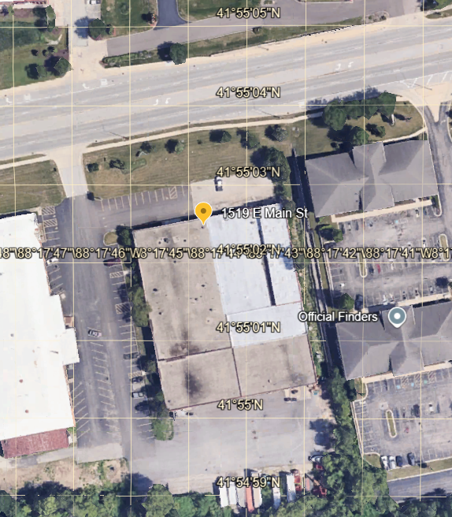

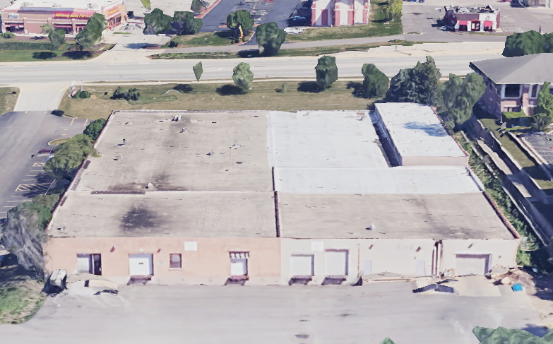

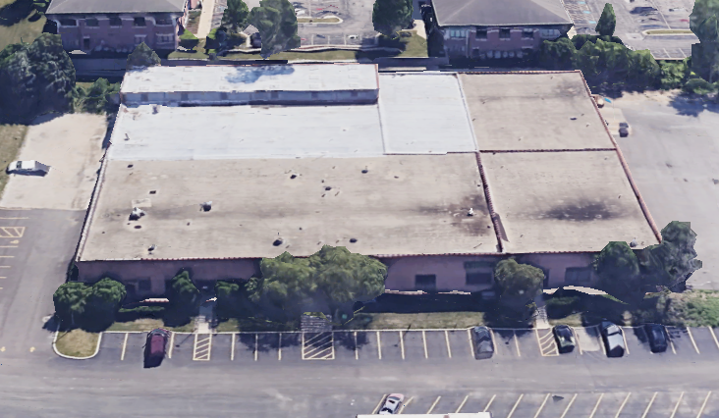

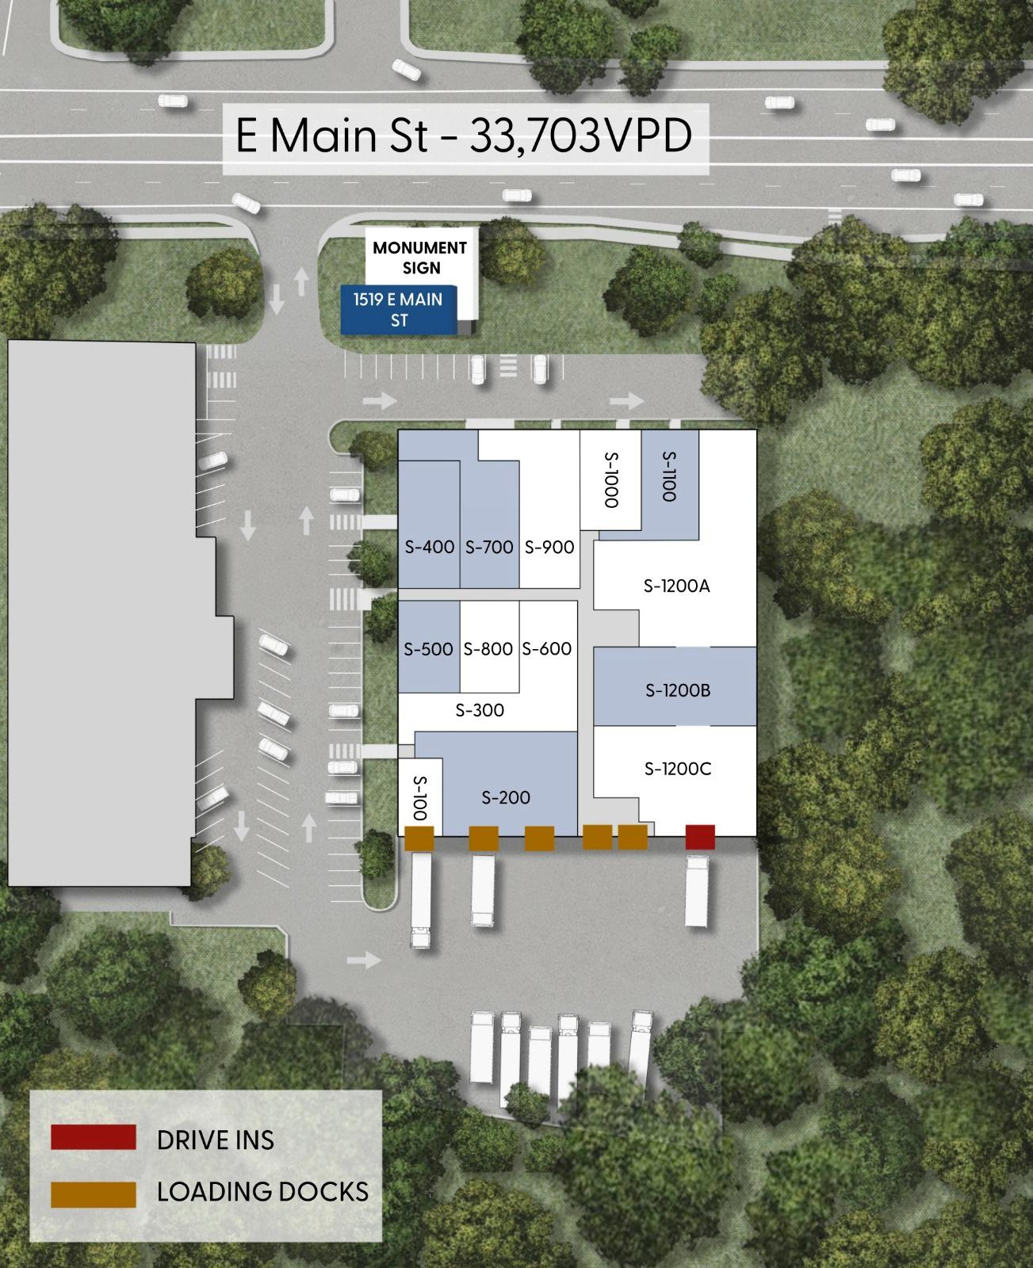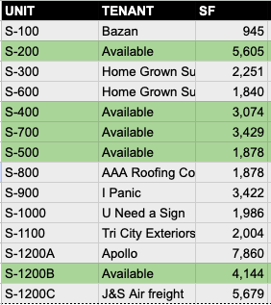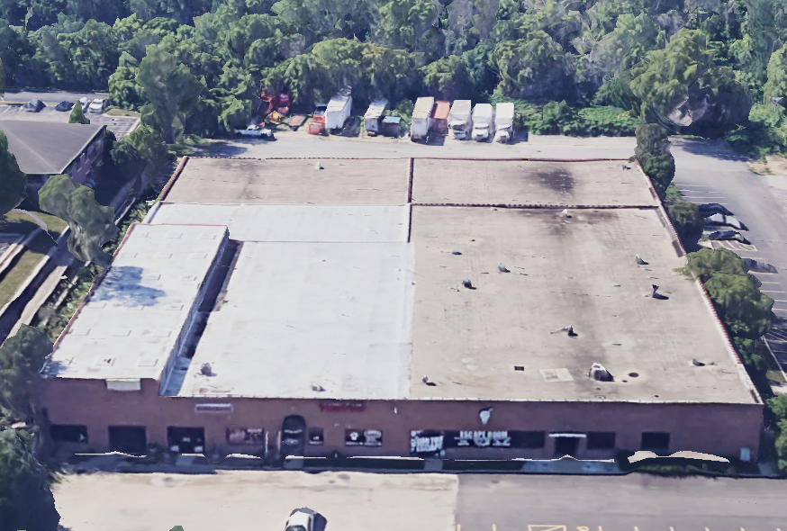

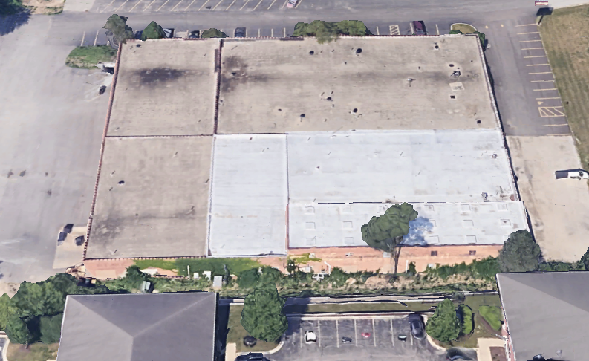

Digital Services for Real Estate Investors - Project Central

This document serves as the central repository for all information related to our new project offering digital services tailored to real estate investors.

# Project Overview

The primary goal of this project is to provide comprehensive digital solutions that empower real estate investors to maximize their returns and streamline their operations. This includes but is not limited to:

* Website development and optimization
* SEO and digital marketing campaigns
* Lead generation and CRM integration
* Data analytics and reporting tools

# Key Stakeholders

| Name | Role | Contact Information |
| --- | --- | --- |
| John Doe | Project Manager | john.doe@email.com |
| Jane Smith | Marketing Lead | jane.smith@email.com |
| Alex Johnson | Development Lead | alex.johnson@email.com |

# Project Timeline

| Milestone | Start Date | End Date | Status |
| --- | --- | --- | --- |
| Project Planning | 2025-05-01 | 2025-05-07 | Completed |
| Requirements Gathering | 2025-05-08 | 2025-05-15 | In Progress |
| Design Phase | 2025-05-16 | 2025-05-23 | Not Started |
| Development Phase | 2025-05-24 | 2025-06-15 | Not Started |
| Testing and QA | 2025-06-16 | 2025-06-22 | Not Started |
| Launch | 2025-06-23 | 2025-06-23 | Not Started |

# Marketing Strategy

* Identify target audience segments within the real estate investor community.
* Develop content marketing strategy focused on industry trends and insights.
* Utilize social media and paid advertising to reach potential clients.
* Create case studies and testimonials showcasing successful partnerships.

# Development Tasks

* Build a user-friendly website with investor-focused features.
* Integrate CRM system for lead management and client communication.
* Implement data analytics tools to track performance and identify areas for improvement.
* Ensure scalability and security of digital platforms.

# Resources

* Project Budget: $50,000
* Team Members: 5
* Tools and Software: CRM, Analytics platform, Development tools

# Notes and Updates

* Regular status meetings will be held every Monday at 10 AM.
* All project-related documents and files will be stored in the shared drive.
* Updates and progress reports will be circulated weekly.

**PT_900-T_Estimate Structure**

| **Deliverable** | **Notes** |
| --- | --- |
| Submittal Formatting & Upload | Files prepared to municipality standard |
| Gurnee Application Management | Filled and submitted with signatures |
| Municipal Liaison & Calls | Including questions, clarifications, scheduling |
| Plan Correction Handling | Includes bubble-marking, resubmittals |
| ADA/Zoning/EPA Compliance Sheets | Tailored to application requirements |
| Owner Communication & Tracking Log | Shared dashboard or PDF report |
| Final Permit Delivery | Stored and shared through TwinModel portal |

Deliverable

Notes

1. Submittal Formatting & Upload

Files prepared to municipality standard

* Gurnee Application Management

Filled and submitted with signatures

Municipal Liaison & Calls

Including questions, clarifications, scheduling

Plan Correction Handling

Includes bubble-marking, resubmittals

ADA/Zoning/EPA Compliance Sheets

Tailored to application requirements

Owner Communication & Tracking Log

Shared dashboard or PDF report

Final Permit Delivery

Stored and shared through TwinModel portal

**Tab 31**

## 13 Jun 2025 | [04_Operations](https://www.google.com/calendar/event?eid=NGhocTV2ZDNvcG52dWpydWhwdXBia2pyMjhfMjAyNTA2MTNUMTMwMDAwWiBncGFyZWRlc0Bwcm9qZWN0b3R3ZW5pdHUuY29t)

Attendees:

Notes

We wanted to clarify with you the following:

1. What's the estimated timeline for the deliverables?

We are about 2 weeks out from being able to start. I anticipate the measurements/existing to be done 2 days after we come out. From there I need a day or 2 to get some concepts going for the proposed plans. Once you appve the proposed plans, I need 1-1.5 weeks to finalize the drawings for permit.  
  
Could you clarify what do you mean with the following: When you say we are 2 weeks out from being able to start

1. Based on your review of the space so far, do you foresee any structural implications for plumbing routing, floor penetrations, or partitions?

I don’t see any structural issued to overcome. The partitions shouldn’t be a problem to be built. The plumbing routing/floor, I don’t have any information to make any recommendations on.

1. Will you be available to clarify design intent or respond to Village comments if they arise during permit review or inspection phases?

We would cover the corrections from the village on our drawings as part of or work. If there are issues during inspections, we would consider that additional scope and charge per hour. We do not include construction administration as part of our scope.

1. Could we align on a revision schedule, or agree on how we will review/comment collaboratively to avoid exceeding the limit.

Yes, not a problem. Being a smaller scope, if we go over the 3 with some minor changes, there will be no extra charge.

1. Will final permit plans be submitted as PDF only, or will we also receive DWG or Revit files for future coordination?

The village needs PDF/or prints. But if you’re asking about sending you things, we can discuss sending you the CADS when it’s permitted. Generally, I don’t have a problem with that as long as a release is signed.

Action items

**05_Finance & Accounting**

**07_Business Planning**

**Prototype Assemply_Rev 062425**

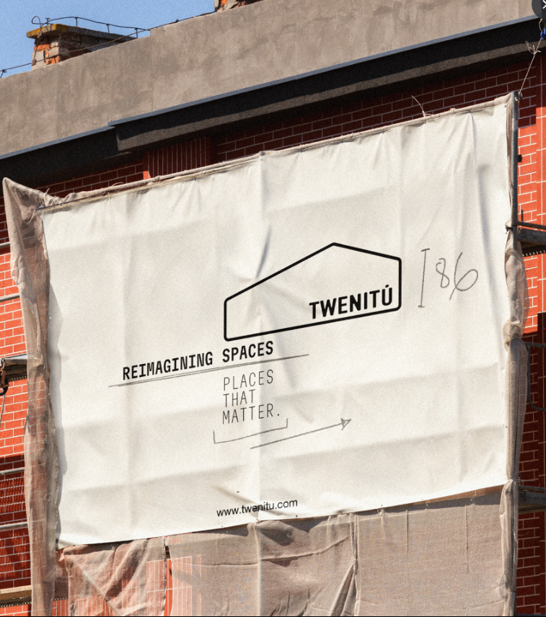

# Twenitú Digital – Prototype Release: Interactive Digital Presentation

## **🎯 Objective**

Launch an innovative, interactive digital prototype presentation (webinar-style) showcasing Twenitú Digital's three core products:

* **TwinScan**
* **TwinModel**
* **TwinShow**

## **📅 Format**

* **Event Type:** Digital Webinar (Live or Pre-recorded Hybrid)
* **Audience:** Potential clients (homeowners, investors, fix & flippers), collaborators (freelancers, subs), industry contacts
* **Presentation Duration:** 30–45 minutes
* **Date: 12 Jun 2025**
* **Delivery Style:** Interactive / Dynamic / Visual-first / Modular blocks

## **🧱 Structure Overview (Sections)**

### **1. Welcome & Brand Vision (3–5 mins)**

* ***Twenitú Purpose & Vision.***
* ***Projecto Twenitu’s Manifesto***  
    
  Do you remember when we were kids or younger and we thought all the buildings in our cities were as easy as building a house in the Sims? Or maybe you didn’t play Sims, but you watch Extreme Makeover. Well Twenitú makes the construction and spaces reimagining as easy as that. Note: we don’t like the word “renovation”, so instead we will be using the following word: Reimage. We think it sounds appealing.

Projecto Twenitú is basically the “father” of a couple of “twins”. These “twins” are basically two sub divisions. They are split in two main divisions: **Twenitú Digital** and **Twenitú Build**.   
  
Our idea is that these two divisions work together to complement each other when the life cycle of a project starts. From digital to physical. From conception to reality. Put an idea in your mind and we will take it, digitalize to extract important information and with tight information in hand you take the decision.  
  
From homeowners to investors. From Fix and Flippers to Engineering and Construction. We are a partner in your process.

* ***What we’re changing: Visual-first, scan-to-decision model***
* ***Introduction to Twenitú.***  
  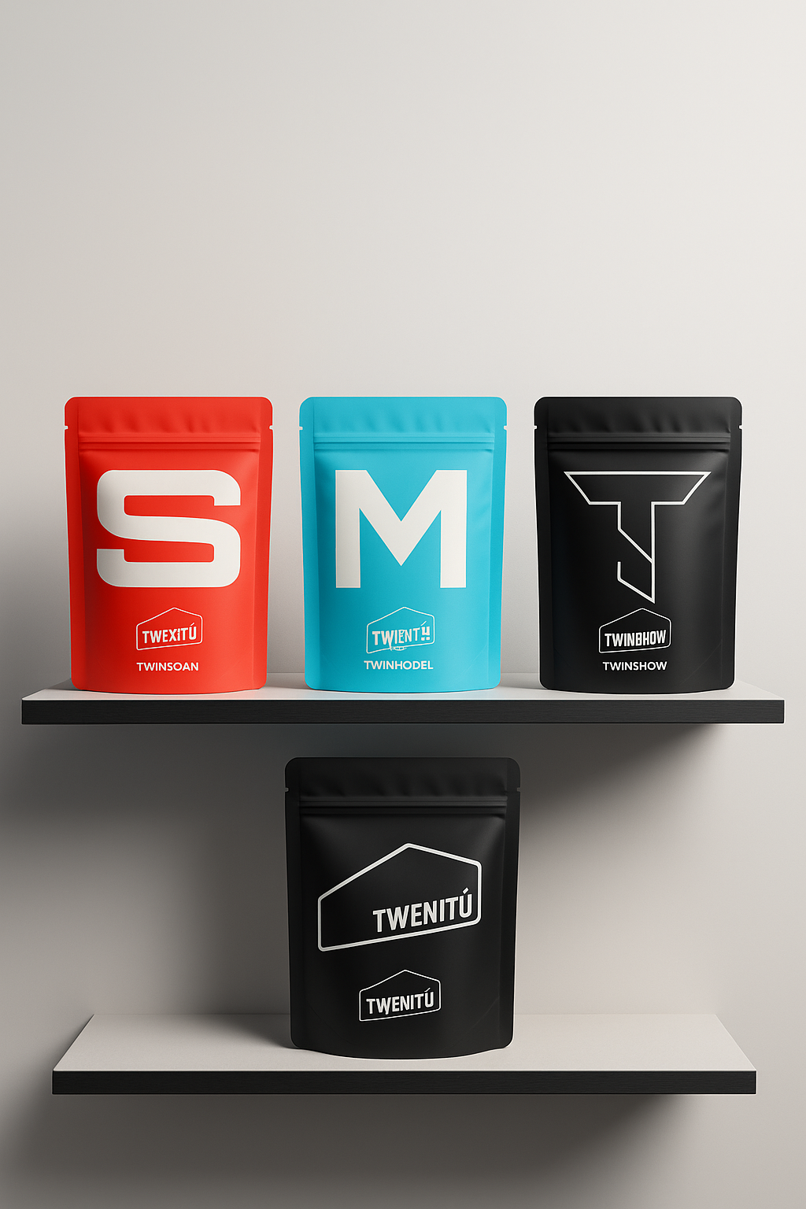

### **2. Product 1 – TwinScan (MVP Focus)**

### 

* ***Problem it solves***
* ***What you get*** *(visual demo: Matterport, tagging, .e57 export)*
* ***Live interaction:*** *Viewers can click through Matterport demo*  
  ¿What would we like to show?

1. PDF.  
   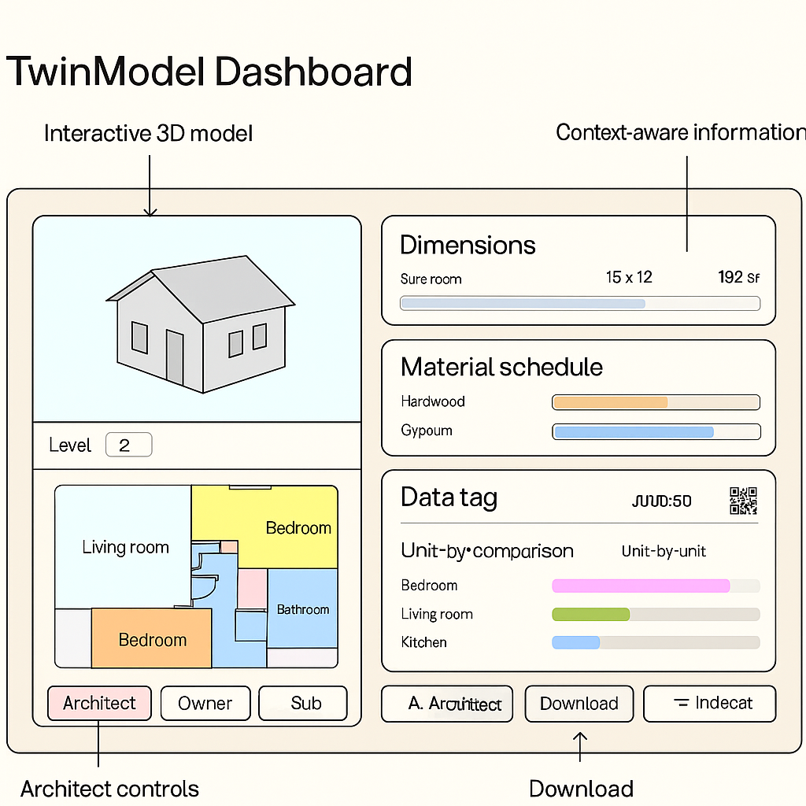
2. Dos
3. Tres

* ***Call to Action (CTA):*** *“Do you know your space?” → Link to scan consultation*

### **3. Product 2 – TwinModel (MVP Focus)**

* 
* ***Problem it solves***
* ***What you get*** *(visual demo: Revit viewer, scheduling sheets, LOD explanation)*

Dashboard Set:

# Financial Forecast Dashboard

| **Section** | **Placement** | **Format** | **Notes** |
| --- | --- | --- | --- |
| **Top KPI Row** | Top horizontal band | Cards (with icons) | Total Rentable SF, Total Rent, Avg Rent/SF, Pro-Rata Load |
| **Base Rent + NNN Breakdown** | Left vertical column | Bar/stacked charts | Split NNN (CAM, Insurance, Tax), with tooltips |
| **Rentable SF & Pro-Rata** | Mid-center panel | Donut or matrix | Show % of common area per room |
| **Geographic Map** | Top-right or modal | Icon Map / native Map | Linked to lat/long per property |
| **Interactive Floor Plan** | Center (dominant) | Synoptic Panel | Clickable, tooltips with rent per room |
| **3D Model Viewer** | Bottom-right | Button or image card | “View in 3D” → opens model |
| **Forecast Chart** | Bottom-center | Area/line chart | Monthly Rent (base + NNN), toggle per year |

# Space Planning Dashboard

| **Section** | **Placement** | **Format** | **Notes** |
| --- | --- | --- | --- |
| **Top KPI Row** | Top (horizontal) | Cards | % Occupancy, Vacant Rooms, Room Count |
| **Interactive Floor Plan** | Center (dominant) | Synoptic Panel or Shape Map | Color by Room Type or Occupancy |
| **Room Type % Breakdown** | Top-right | Stacked bar or pie | Auto-groups: Office, Retail, Storage, etc. |
| **Interactive 3D Model** | Right or modal | Speckle / Twinmotion Link | Passive visual or embedded image viewer |
| **Matterport Integration** | Bottom-left | Click-to-open preview or link | Add toggle to “walk space” |
| **Room Tag Table** | Bottom | Table: Room ID, Area, Type | With search or filter for fast zoom |

# Construction Dashboard

| **Section** | **Placement** | **Format** | **1** | **2** | **3** | **Notes** |
| --- | --- | --- | --- | --- | --- | --- |
| **Top KPI Cards** | Top row | Cards: Total Construction Cost, Permit Cost, Total SF |  |  |  | High-level construction financials |
| **Interactive Floor Plan (Phased)** | Center | Synoptic or Shape Map |  |  |  | Toggle by Discipline (MEP, Struct, Arch) |
| **3D Model by Discipline** | Right panel | Speckle/iframe preview + switch |  |  |  | Use layers for MEP/Arch/Struct |
| **Licensed Professional Costs** | Left panel | Table or expandable cards |  |  |  | Name, Role, Cost, License # |
| **Subcontractor Breakdown** | Bottom | Matrix: Scope × Cost |  |  |  | Include toggles or tooltips for notes |
| **Material Take-Offs & Costs** | Modal or Drillthrough | Table or heatmap |  |  |  | Filter by level or type |
| **Permit Costs** | KPI card or sidebar | Single number + breakdown |  |  |  | Include jurisdiction + stage |
| **Other Costs** | Bottom cards | Cards with expandable details |  |  |  | Use “info” icon tooltips |

## Value added:

* Data
* Understand
* Financial
* Time
* Insights
* Information
* Costs
* Visuals
* Numbers
* Percentage
* Forecasts
* Schedule
* Planing
* Logistics
* ***Live interaction:*** *Drag LOD slider or change room layouts*  
  ¿What would we like to show?

1. Uno
2. Dos
3. Tres

* ***CTA:*** *“Visualize your next move” → Link to model test form*

### **4. Product 3 – TwinShow (MVP Focus)**

* 
* ***Problem it solves***
* ***What you get*** *(demo: Twinmotion walkthrough, pre/post toggle, sun effect simulation)*
* ***Live interaction:*** *Choose materials, trigger walkthrough scene*¿What would we like to show?

1. Uno
2. Dos
3. Tres

* ***CTA:*** *“Design your decision” → Link to interactive tour demo*

### **5. Prototype Showcase**

## **Matterport Digital Twin**

### **Electric Company Loft**

### **.**

* 3D Visualization
* Phases.
* Floor Plan As-Is
* Floor Plan Proposal
* Material Schedule
* Material Quantification
* Material Schedule

### **Twinmotion**

* Materials Toggle Option.
* Walkthrough-
* Renders.
* Virtual Reality.

### **6. Q&A or Live Chat Room (5–10 mins)**

### **7. Closing / Thank You / Next Steps (2 mins)**

* *CTA to work with Twenitú (Form link)*
* *Special offer or invitation to join early adopters*

## **📦 For Each Product: Define MVP Before Event**

* *3 deliverables maximum*
* *1 interactive viewer or web output*
* *1 client-facing PDF/visual slide*
* *1 tangible benefit made visual*

| Division | Service | Key Components | Main Deliverables |
| --- | --- | --- | --- |
| **Digital** | **TwinScan** | • Matterport scan  • Zone tagging  • Area segmentation by level or space  • Point cloud export (.e57 / .rcp)  • Reference site map | • Matterport scan link  • Point cloud file  • Zone-based scan map  • Room/space tags |
| **Digital** | **TwinModel** | • Revit model with LOD 100–500 depending on scope  • Worksets by discipline  • Architectural plans and RCPs  • 3D views  • Material schedule | • Revit file (.rvt)  • PDF plan set  • Export as 3D PDF / .DWFx  • LOD summary sheet  • Material and room tag schedule |
| **Digital** | **TwinShow** | • Twinmotion export  • Interactive material selector  • Before/after visual toggle  • Lighting scenes setup | • Render image package  • Virtual walkthrough  • Twinmotion file (.tm)  • Shareable web viewer link |
| **Build** | **SpaceReimage** | • Selective demolition  • Light remodeling  • Finish upgrades | • Daily photo log  • Before/after comparison  • Completion sign-off certificate |
| **Build** | **SpaceBuild** | • Full interior construction  • Layout buildout  • MEP trades coordination | • Site progress reports  • Daily/weekly logs  • Labor tracking sheets  • Installation checklist |
| **Build** | **SpaceMaintain** | • Periodic maintenance  • Repair evaluations  • Asset/equipment registry | • Maintenance logbook  • Service verification reports  • Photo documentation of condition and resolution |

#### Note: The SpaceMaintain service is designed as an optional maintenance plan that can be included as added value in any Digital or Build project. During this prototype phase, it will be offered at no extra cost and explained to the client. In the future, it will evolve into a standalone service with an annual subscription model.

**Prototype Assemply_Outdated**



# Twenitú Digital – Prototype Release: Interactive Digital Presentation

## **🎯 Objective**

Launch an innovative, interactive digital prototype presentation (webinar-style) showcasing Twenitú Digital's three core products:

* **TwinScan**
* **TwinModel**
* **TwinShow**

## **📅 Format**

* **Event Type:** Digital Webinar (Live or Pre-recorded Hybrid)
* **Audience:** Potential clients (homeowners, investors, fix & flippers), collaborators (freelancers, subs), industry contacts
* **Presentation Duration:** 30–45 minutes
* **Date: 12 Jun 2025**
* **Delivery Style:** Interactive / Dynamic / Visual-first / Modular blocks

## **🧱 Structure Overview (Sections)**

### **1. Welcome & Brand Vision (3–5 mins)**

* ***Twenitú Purpose & Vision.***
* ***Projecto Twenitu’s Manifesto***  
    
  Do you remember when we were kids or younger and we thought all the buildings in our cities were as easy as building a house in the Sims? Or maybe you didn’t play Sims, but you watch Extreme Makeover. Well Twenitú makes the construction and spaces reimagining as easy as that. Note: we don’t like the word “renovation”, so instead we will be using the following word: Reimage. We think it sounds appealing.

Projecto Twenitú is basically the “father” of a couple of “twins”. These “twins” are basically two sub divisions. They are split in two main divisions: **Twenitú Digital** and **Twenitú Build**.   
  
Our idea is that these two divisions work together to complement each other when the life cycle of a project starts. From digital to physical. From conception to reality. Put an idea in your mind and we will take it, digitalize to extract important information and with tight information in hand you take the decision.  
  
From homeowners to investors. From Fix and Flippers to Engineering and Construction. We are a partner in your process.

* ***What we’re changing: Visual-first, scan-to-decision model***
* ***Introduction to Twenitú.***  
  

### **2. Product 1 – TwinScan (MVP Focus)**

### 

* ***Problem it solves***
* ***What you get*** *(visual demo: Matterport, tagging, .e57 export)*
* ***Live interaction:*** *Viewers can click through Matterport demo*  
  ¿What would we like to show?

1. PDF.  
   
2. Dos
3. Tres

* ***Call to Action (CTA):*** *“Do you know your space?” → Link to scan consultation*

### **3. Product 2 – TwinModel (MVP Focus)**

* 
* ***Problem it solves***
* ***What you get*** *(visual demo: Revit viewer, scheduling sheets, LOD explanation)*
* ***Live interaction:*** *Drag LOD slider or change room layouts*  
  ¿What would we like to show?

1. Uno
2. Dos
3. Tres

* ***CTA:*** *“Visualize your next move” → Link to model test form*

### **4. Product 3 – TwinShow (MVP Focus)**

* 
* ***Problem it solves***
* ***What you get*** *(demo: Twinmotion walkthrough, pre/post toggle, sun effect simulation)*
* ***Live interaction:*** *Choose materials, trigger walkthrough scene*¿What would we like to show?

1. Uno
2. Dos
3. Tres

* ***CTA:*** *“Design your decision” → Link to interactive tour demo*

### **5. Prototype Showcase**

## **Matterport Digital Twin**

### **Electric Company Loft**

### **.**

* 3D Visualization
* Phases.
* Floor Plan As-Is
* Floor Plan Proposal
* Material Schedule
* Material Quantification
* Material Schedule

### **Twinmotion**

* Materials Toggle Option.
* Walkthrough-
* Renders.
* Virtual Reality.

### **6. Q&A or Live Chat Room (5–10 mins)**

### **7. Closing / Thank You / Next Steps (2 mins)**

* *CTA to work with Twenitú (Form link)*
* *Special offer or invitation to join early adopters*

## **📦 For Each Product: Define MVP Before Event**

* *3 deliverables maximum*
* *1 interactive viewer or web output*
* *1 client-facing PDF/visual slide*
* *1 tangible benefit made visual*

| Division | Service | Key Components | Main Deliverables |
| --- | --- | --- | --- |
| **Digital** | **TwinScan** | • Matterport scan  • Zone tagging  • Area segmentation by level or space  • Point cloud export (.e57 / .rcp)  • Reference site map | • Matterport scan link  • Point cloud file  • Zone-based scan map  • Room/space tags |
| **Digital** | **TwinModel** | • Revit model with LOD 100–500 depending on scope  • Worksets by discipline  • Architectural plans and RCPs  • 3D views  • Material schedule | • Revit file (.rvt)  • PDF plan set  • Export as 3D PDF / .DWFx  • LOD summary sheet  • Material and room tag schedule |
| **Digital** | **TwinShow** | • Twinmotion export  • Interactive material selector  • Before/after visual toggle  • Lighting scenes setup | • Render image package  • Virtual walkthrough  • Twinmotion file (.tm)  • Shareable web viewer link |
| **Build** | **SpaceReimage** | • Selective demolition  • Light remodeling  • Finish upgrades | • Daily photo log  • Before/after comparison  • Completion sign-off certificate |
| **Build** | **SpaceBuild** | • Full interior construction  • Layout buildout  • MEP trades coordination | • Site progress reports  • Daily/weekly logs  • Labor tracking sheets  • Installation checklist |
| **Build** | **SpaceMaintain** | • Periodic maintenance  • Repair evaluations  • Asset/equipment registry | • Maintenance logbook  • Service verification reports  • Photo documentation of condition and resolution |

#### Note: The SpaceMaintain service is designed as an optional maintenance plan that can be included as added value in any Digital or Build project. During this prototype phase, it will be offered at no extra cost and explained to the client. In the future, it will evolve into a standalone service with an annual subscription model.

**BID Package_Digital**

Twenitú Digital – Request for Proposal Template

1. Invitation to Bid (Digital Division)

## Subject: Request for Proposal – [Project Name] – Twenitú Digital

#### Description: We are soliciting proposals from qualified digital modeling/scanning freelancers or vendors for [Project Name].

#### Submission Deadline: [Insert Date]

#### Contact: [Your Email & Phone Number]

## Project Overview

#### Project Type: Digital Twin / Building Information Modeling (BIM) / 3D Scanning

#### Scope Focus: Precision, modeling efficiency, and file compatibility

#### Division: Twenitú Digital

## Scope of Work – Digital Bundles

#### TwinScan: Matterport or LiDAR-based scanning (performed exclusively by Twenitú Digital)

#### TwinModel: As-built Revit/BIM modeling derived from scan data

#### TwinShow: Rendered visualizations, animated walkthroughs, or Twinmotion exports

#### Optional Services: DWG file refinement, data conversion, texture mapping, and level coordination

## Reference Materials

#### Matterport link (if applicable)

#### Revit template (if required)

#### Existing DWG or PDF documents

## Project Timeline

#### Scanning Completion: [Date]

#### Modeling Commencement: [Date]

#### Final Deliverable Submission: [Date]

## Pricing Schedule

| Bundle | Description | Unit | Rate |
| --- | --- | --- | --- |
| TwinModel | As-built Revit Model | per sq. ft. | ____ |
| TwinShow | Visualization or Animated Walkthrough | per scene/min | ____ |

## Submission Requirements

#### Format: PDF document or secure shared folder link

#### Required Inclusions: Portfolio, Certificate of Insurance (COI), Non-Disclosure Agreement (NDA) (if applicable), and Form W-9

## Terms and Conditions

#### Fixed Fee or Time and Materials (T&M) engagement

#### Net 15 / Net 30 payment terms

#### 30% deposit (optional)

## Evaluation Criteria

#### Quality of portfolio (BIM accuracy and visual presentation)

#### Timeliness and adherence to standard templates

#### Pricing and responsiveness

**BID Package_Build**

Twenitú Build – Request for Proposal Template

1. Invitation to Bid (Build Division)

## Subject: Trade Proposal Solicitation – [Project Name] – Twenitú Build

#### Description: We are seeking a trade partner to execute [Scope] for [Project Name].

#### Submission Deadline: [Insert Date]

#### Contact: [Your Email & Phone Number]

## Project Overview

#### Project Type: Residential Renovation (kitchen, bathroom, flooring, etc.)

#### Location: [Site Address]

#### Division: Twenitú Build

## Service Categories (Product Types)

#### SpaceReimage: Surface enhancements and cosmetic upgrades

#### SpaceBuild: Structural modifications or comprehensive remodeling projects

#### SpaceMaintain: Repairs, patching, and adjustments

## Reference Documents

#### Floor Plans / Elevations

#### Job site photographs

#### Scope-specific drawings (demolition plans, installation specifications)

## Project Schedule

#### Job Site Walkthrough: [Date]

#### Work Commencement: [Date]

#### Estimated Project Duration: [X Days/Weeks]

## Pricing Schedule

| Trade | Task | Unit | Rate |
| --- | --- | --- | --- |
| Demolition | Complete Bathroom Gutting | Lump Sum | ____ |
| Tile Work | Floor and Wall Installation | per sq. ft. | ____ |
| Plumbing | Rough-in and Trim Out | per fixture | ____ |

## Submission Requirements

#### Format: PDF document and completed pricing schedule

#### Required Documentation: Certificate of Insurance (COI), Form W-9, General Contractor License, and Portfolio (photographs preferred)

## Terms and Conditions

#### Fixed Price or Time and Materials (T&M) agreement (as specified)

#### Retainage: 10% until final completion and punch list items are resolved

#### Payment: Net 30 days (unless otherwise negotiated)

## Evaluation Criteria

#### Proven experience in residential renovation

#### Compliance with licensing and safety regulations

#### Effective communication and timely responses

Normal

Title

Subtitle

# Heading 1

## Heading 2

### Heading 3

**Cost Structure**

## horizontal line



PROJECTO TWENITÚ

Cost Structure

5 May 2025

Gabriel Paredes

PROJECTO TWENITÚ

1751 N Western Ave.

Chicago, Illinois. 60647.

# Overview

# Goals

# Specifications

## Lorem Ipsum

# Milestones

## Lorem ipsum

## Dolor sit amet

**Foundations**

## horizontal line



PROJECTO TWENITÚ

1 May 2025

Gabriel Paredes

PROJECTO TWENITÚ

1751 N Western Ave.

Chicago, Illinois. 60647.

# Overview

Projecto twenitú is a Tech-Driven Construction company based in Chicago. Founded by Gabriel Paredes, a Mechanical Engineer from Venezuela. Gabriel brings his personal and professional experience to this project.

Gabriel was born and raised in a coastal hometown in Anzoategui, Venezuela named Guanta. His father worked for over 25 years in CEMEX (Cementos Mexicanos) and he and his family relocated to Vencemos, a small neighborhood where 20 of the most important employees of the Cement Production Plan were relocated. This was in the proximity of the CEMEX Quarry and plant production. Also, it is important to highlight that all of his childhood he was surrounded not just by Employees who worked in the company, but the President, Director, Manager, and other important people from the industry.

Having this experience of witnessing how the “Cement” was produced from the exploitation of the quarry until the exportation of the product, helped him to understand the very basics of the construction field.

At 21; While Gabriel was still in the Mechanical Engineer career path, he was invited to be part of a partnership. This partnership was the beginning of his career in the construction field. Having his mother (attorney) created the company in just a couple of days, he and his partner started to execute small renovation projects.   
  
After 5 years of partnerships, Gabriel decided to take his path and start a company more inclined to Digital Construction, Four Walls Development was created in Lecheria

# Goals

1. Enhancing the Construction Field by implementing technologies.
2. Creating a brand, not just a company, that customers feel related with.

# Specifications

Lorem Ipsum

# Operations Strategy

#### Projecto twenitú will be structured in two main divisions. Twenitú Digital and Twenitú Build.

## Division 1. Twenitú Digital.

### **🔹 Division Purpose**

Twenitú Digital supports every phase of a construction or renovation project by capturing, modeling, and simulating existing and proposed conditions. It helps clients and field teams make smarter, faster, and more coordinated decisions — before, during, and after construction.

This division acts as the **bridge between reality and execution** — using technology to translate existing conditions into actionable visuals, data, and coordination tools.

## *Scope:*

#### 1. Matterport Services

* High-resolution 3D Digital Twin capture
* Site walk-throughs for remote coordination
* Matterport Digital Twin Editions:
* Architectural Tags (walls, slabs, heights)
* MEP Tags (visible HVAC, plumbing, electrical)
* Structural Tags (columns, beams, etc.)
* Pictures and snapshots extracted from scans
* Matterpak Bundle or E57 for integration with CAD/BIM tools

#### 2. Revit & BIM Modeling

* As-built Modeling from Scans
* Architectural shell
* MEP rough-ins
* Structural layouts
* Demolition Plans (based on scanned conditions)
* Proposed Layout Options (multiple plan scenarios)
* BIM Coordination Support with levels, grids, and section views
* Centralized models for team access

#### 3. Project Simulation & Visualization

* Twinmotion Simulations for walkthroughs or design presentations
* Lighting & material visualizations (if requested)
* Staging simulations for owners or developers

#### 4. PDF Deliverables

* 2D Floor Plans with tags:
* Room Numbering & Naming
* SQ FT per Room
* Ceiling & Beam Heights
* View-specific PDFs for layout review or permit submittals
* Optional overlays: proposed vs. existing

# Research:

13 May 2025

IPX BIM Podcast_Buildings 2.0_Integrated Projects’ Thomas Czerniawski  
  
<https://youtu.be/eC3nY13wQMc?list=PLjkuBsitFwVeVHn6vpnaGCpt5Eywz454N>

### **Key aspects and notes:**

* Laser Scanning is the bridge between the physical word and the digital word

### **For assistant:**

* Can we start determining how we can aim our service to our potential customers?
* For example, we have a product that could be used for many industries such as Real Estate Investor or Developer, General Contractors, new homeowners (interested in having their home scanned for Maintenance Reasons), etc.
* How can we determine the pain of our customers?
* Understanding our customers needs, requirements and pains:  
    
  **- Homeowners:**   
  This type of customer can have their home and investment scanned so they can understand their property and improve their maintenance process. By having their property Digital Twin, homeowners can communicate better with the different types of contractors they can have in their future years. Contractors such as HVAC, Plumber, Electricians, Cleaning can use the Digital Twin to understand the property if a problem arises.  
    
  Do I have the time to go around the home to find specs or counts of something?  
    
    
  **LOD needed: 200**  
    
  **- General Contractors:**  
  General contractors can use the Digital Twins in every process of their operations. Since preconstruction phase to post construction phases, they can use the Digital Twin to bridge the gap between offices, stakeholders, etc with the project.  
    
  **LOD needed: 300-600**  
    
  **- Real Estate Investors:**This niche can use the Digital Twin and BIM to understand their investment. By implementing BIM to their project they can know exactly the square footage they are buying, and not just the square footage but also their cube footage or however is called. Understanding and knowing what volume they can take advantage of all of their spaces. By knowing all this information they can communicate with all their sub contractors, and stake holders.  
    
  **LOD needed: 300**  
    
  **- Real Estate Agents:**

This customer needs to understand the property they are selling in order to have more power in the selling moment. If they know the property already before visiting it with potential buyers, he will be able to have the lead in the walk-in process. If they are doing a virtual walkthrough through videocall with the customer he is able to have all the information of the property in this Digital Twin.

**LOD needed: 100 - 300**

**Restaurant Owners and investors:**

This type of business has an overwhelming lifecycle. These facilities usually work 6 days per week at least 8 hours a day. With many equipment, MEP, and different architectural elements they need to have maintenance plans very well implemented. To have good maintenance plans implemented they need to understand their facilities and all the elements within it. Since a fryer that gets damaged to the Dishwasher equipment. Since the front door and host area to the main floor.  
  
Understanding their MEP helps them to address issues rapidly. HVAC systems fail down and if the restaurant is in a seasonal region this is more prompt to happen. Plumbing systems get clogged and need to be unclogged as soon as possible so the restaurant is actively operating without having to shutdown. Electrical systems are overcharged and fail down and we want to know exactly where the electrical elements are. Equipment fails down and restaurant owners don't know how they were installed.  
 **LOD needed: 100 - 300**

## Division 2: Twenitú Build.

### **🔹 Division Purpose**

Twenitú Build delivers high-quality construction and renovation services that are **fueled by data, precision, and visualization** created by Twenitú Digital. This division is where your ideas, layouts, and models are executed on-site with craftsmanship, coordination, and care.

It bridges **design intent with field execution**, ensuring that construction aligns perfectly with visualized expectations.

## *Scope:*

#### 1. Interior Renovations

* Full **kitchen renovations**
  + Demolition, plumbing/electrical adjustments, cabinet installation, countertop & backsplash, painting, flooring
* Full **bathroom renovations**
  + Demolition, waterproofing, plumbing/electrical relocations, tile, vanity installation
* **Basement finishing** (with or without layout redesign)
* **Living spaces**: millwork, flooring, door & trim upgrades

#### 2. Surface & Finish Work

* Hardwood floor refinishing or replacement  
  Tile work (bathrooms, kitchens, flooring)
* Interior painting & drywall repair
* Trim carpentry: casing, baseboards, crown molding
* Cabinetry adjustments or replacements

#### 3. Custom Installations

* Millwork walls or built-ins based on 3D mockups
* Custom lighting fixture installs as per digital layouts
* Smart Home device integration (optional add-on)

#### 4. Small Structural Modifications

* Non-load-bearing wall removals (based on scanned layout validations)
* Framing reconfiguration for new layouts
* Drop ceiling adjustments per beam height models

#### 5. Field Coordination

* Construction phase guided by **Revit Layouts** and **PDF sets**
* Use of **Matterport QR tags** on-site for visual references
* Continuous communication between digital and field team

#### 6. Post-Construction Services

* Punch-list completion walkthrough (can be documented digitally)
* Re-scanning (if needed) to validate completed conditions
* Maintenance guide creation (as an add-on)

# Competitors

| **Name** | **Competitor Impression** | **Service Focus** | **Webpage** |
| --- | --- | --- | --- |
| 123 Remodeling | Bueno 👍🏽 | Kitchen, Bathroom, Condo Remodeling | <https://123remodeling.com/> |
| Chi Renovation & Design | Bueno 👍🏽 | Kitchen, Bathroom, Basement Remodeling | <https://www.chirenovation.com/> |
| 4Ever Remodeling | Que va 👎🏽 | Bathroom Remodeling | <https://4everremodeling.com/> |
| 312 Kitchen & Bath | Mas o Menos 🤏🏽 | Kitchen & Bath Remodeling | <https://www.312kitchenbath.com/> |
| Masters Kitchen & Bath | Mas o Menos 🤏🏽 | Kitchen & Bathroom Remodeling | <https://masterskitchenbath.com/home/> |
| IPX (Integrated Projects) | Bueno 👍🏽 | As-Built Plans & BIM Conversion | <https://www.integrated-projects.com/> |
| Cushing | Que va 👎🏽 | 3D Laser Scanning | <https://cushingco.com/3d-laser-scanning-services> |
| Reality Capture Experts | Que va 👎🏽 | Matterport 3D Capture Services | <https://realitycaptureexperts.com/contact-matterport-service-provider/chicago-illinois/> |
| View My Space | Mas o Menos 🤏🏽 | 3D Digital Twin Services | <https://www.viewmyspace.com/> |
| VIATechnik | Mas o Menos 🤏🏽 | BIM Consulting Services | <https://www.viatechnik.com/locations/bim-consulting-services-chicago/> |
| Tejjy Inc. | Mas o Menos 🤏🏽 | BIM Modeling & Coordination | <https://www.tejjy.com/bim-services-chicago-illinois/> |
| United-BIM | Mas o Menos 🤏🏽 | BIM Services | <https://www.united-bim.com/chicago-bim-illinois/> |
| Block Renovation | Bueno 👍🏽 | Renovation | <https://www.blockrenovation.com/> |
| Spacewell | 🤚🏽 | Real Estate Management | <https://spacewell.com/> |
| Tango Analytics | Mas o Menos 🤏🏽 | Real Estate Management | <https://tangoanalytics.com/> |
| Open Space | Mas o Menos 🤏🏽 | Bim Services | <https://www.openspace.ai/> |
| Versatile | 🤚🏽 | Cranes | <https://www.versatile.ai/es-es> |
| Icon Build | Bueno 👍🏽 | Tech Construction | <https://www.iconbuild.com/> |

Founder & Project Manager  
Mechanical Engineer  
**Projecto Twenitú***Space Engineering & Construction***Space Reimagined · Kitchens · Bathrooms**

**Conversation with Stuart (Ken Brenner Friend)**

# Stuart Conversation

## **Polish Newspapers:**

* <https://www.w3newspapers.com/poland/>

## **Insurance:**

* Liability Insurance.
* Binder fast insurance.
* Work Compensation.

## **Village Permit:**

* Design of proposal.

## **Stuart Background:**

* Carpet Cleaning, Decks Refinishing,

**Formating_Paragraph Styles**

Normal

Title

Subtitle

# Heading 1

## Heading 2

### Heading 3

**08_Sales Promotions & Management**

## horizontal line



PROJECTO TWENITÚ   
08_Sales Promotions & Management

14 May 2025

**─**

Gabriel Paredes

Projecto Twenitú LLC

1751 N Western Ave.  
Chicago, IL. 60647.



* **Brick Color**

#C3703D  
  
RGB: 195 112 61

* **Sage Green**

#A6BBAC

RGB: 166 187 172

* **Green #2:**

#9D9759

RGB: 157 151 89

* **Black:**

#000000

RGB: 0 0 0

* **White:**

#FFFCF5

RGB: 255 252 245

Typography:

Martian Mono Condensed  
PP Neue Montreal

**Twenitú Communcations**

This document will serve as the central space to collect, organize, and refine all official communications for Twenitú — including social media captions, announcements, campaign messaging, and internal statements.

### **BRAND DESCRIPTION · 2025**

**Twenitú** is a company focused on reimagining and reengineering spaces. With two integrated divisions — **Twenitú Digital** and **Twenitú Build** — we offer solutions that blend technical precision, intelligent design, and advanced technology to transform spaces into energetic and functional environments.

We exist to unlock the hidden potential in every space. Inspired by our heritage and roots, we help people, families, and investors see beyond walls, plans, and details — to see what their spaces can truly become.

We reimagine. We breathe life and energy into space using precise data, realistic visualizations, and flawless, caring execution.

**We build meaning.**

### **BRAND CONTEXT**

It’s no secret that people often feel like the construction and renovation industry can’t be trusted. Projects come out of nowhere, prices inflate without explanation, and delays pile up — shaking confidence and damaging the industry’s reputation.

A lack of transparency and genuine connection to client needs has left many customers frustrated.

That’s why we created Twenitú — to change that.

Our business model blends **engineering with empathy**, giving new life to spaces through a more personal, collaborative process. We listen. We connect. And by understanding not just what clients need, but *why* they need it — we earn trust and deliver with intention.

We exist to see potential where others see problems. To design with feeling. To build with care.

**We build meaning.**

That’s where we come in.

### **VISION**

To lead a change in mindset — encouraging a future where giving a second life to existing spaces is prioritized over building new ones.

### **MISSION**

To reimagine, reengineer, and give spaces a second life—to see beyond their limits, tap into their hidden potential, and give every space the value it deserves.

### **BRAND VALUES**

**Love the process as much as the result** – We enjoy every step. It’s important for us to do things with dedication from the beginning, focusing on loving every second — not just the final result.

**Care about them** – Our clients mean everything to us. By getting to know them and genuinely caring, we ensure we offer the best service possible.

**See beyond** – We believe every space is as important as the next. We see potential in every corner because we look deeper — beyond what’s visible, toward what’s possible.

### **BUYER PERSONAS**

**The Discerning Client***Age: 40–60*An American client seeking a construction company that offers personal connection over corporate bureaucracy. They value passion, shared vision, and a hands-on team that brings a sense of belonging—prioritizing trust and values over big-name firms.

**The Latino Business Owner***Age: 35–45*A Latino entrepreneur seeking collaborators for a meaningful construction project rooted in cultural values. They want partners who respect their vision and avoid the cold, bureaucratic approach of large corporations—favoring authenticity, emotional connection, and cultural resonance.

**The Ambitious Contractor***Age: 35–50*A second-generation contractor leading a family-run construction firm. Rooted in traditional craftsmanship, now focused on modernizing with tech that supports skilled labor. They value partnerships with like-minded small firms that prioritize quality, experience, and smart innovation.

**The Visionary Project Owner***Age: 25–40*A visionary real estate entrepreneur focused on transforming abandoned spaces into sustainable, community-oriented housing. Frustrated by resistant contractors, they seek like-minded partners to bring their bold, adaptive reuse ideas to life.

### **BRAND PHILOSOPHY**

**The key isn't more spaces — it's better understanding.**

Every space holds a story. So does every person. Just like you, your space is meant to evolve. That’s why we believe people and spaces can grow together — through every chapter of life.

For us, discovery is everything. We take time to listen — to you, your space, and the unspoken potential it holds. Because our work begins with connection, and thrives on understanding your needs and what you truly want your space to become.

We don’t just rebuild.  
We reimagine.  
We reengineer.  
We give spaces a second life.

The potential is already there — in your land, your floors, your walls, your windows. In the structure patiently waiting for its next chapter.

We’re here to honor that potential with technical precision and heartfelt intention.

Our team brings diverse backgrounds and perspectives, because just like your space, our own stories shape how we see what’s possible.

**Your space matters.  
Let’s build meaning.**

### **BRAND PERSONALITY**

Twenitú is practical and visionary. His engineering background shines through often, but he’s also a dreamer — someone who sees beyond blueprints and materials.

He thrives on helping people imagine, bring to life, and live in their reimagined spaces. For Twenitú, uncovering the hidden potential in every environment is essential, and it always starts with listening.

He values the perspectives, input, and stories of those around him — the people who help bring a second life to each space. His energy is calm, magnetic, and inspiring, making people feel welcome and understood.

That connection is what allows him to uncover not just what clients want, but *why* they want it — and to guide them toward building with clarity and heart.

### **TONE & VOICE**

**Passionate** – His love for this work is undeniable. His words reflect how deeply he cares about people, spaces, and what they can become.

**Creative** – He speaks with vision and clarity. His ideas inspire, while making room for others to express theirs. Artistry and experience walk hand-in-hand.

**Professional** – He knows what he’s doing, and it shows. His confidence is grounded in knowledge, preparation, and purpose.

**Empathetic** – He listens. He respects. He adjusts. He cares about the people who trust him with their spaces — and honors that trust with humility and excellence.

**Twenitú_Manifesto**

Manifesto

Vision

Purpose

**Twenitú_Brand Proposal**

# Slide 1

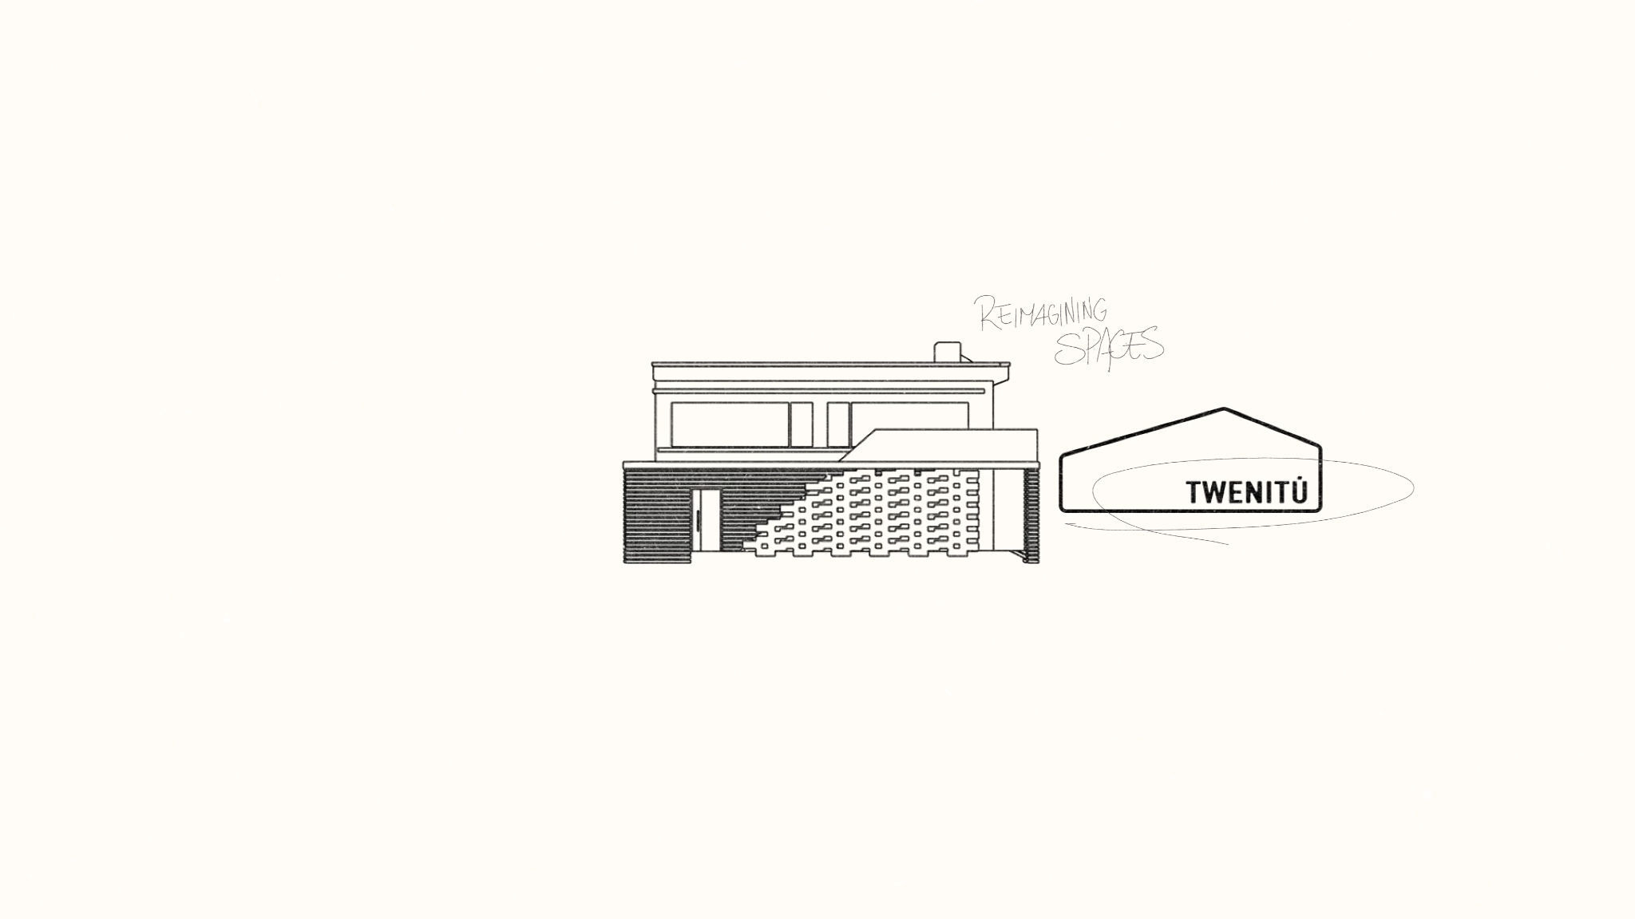Illustration of a building. Handwritten: "REIMAGINING SPACES" Logo shape with "TWENITÚ"

## Comments:

* 1
* 2
* 3

# Slide 2

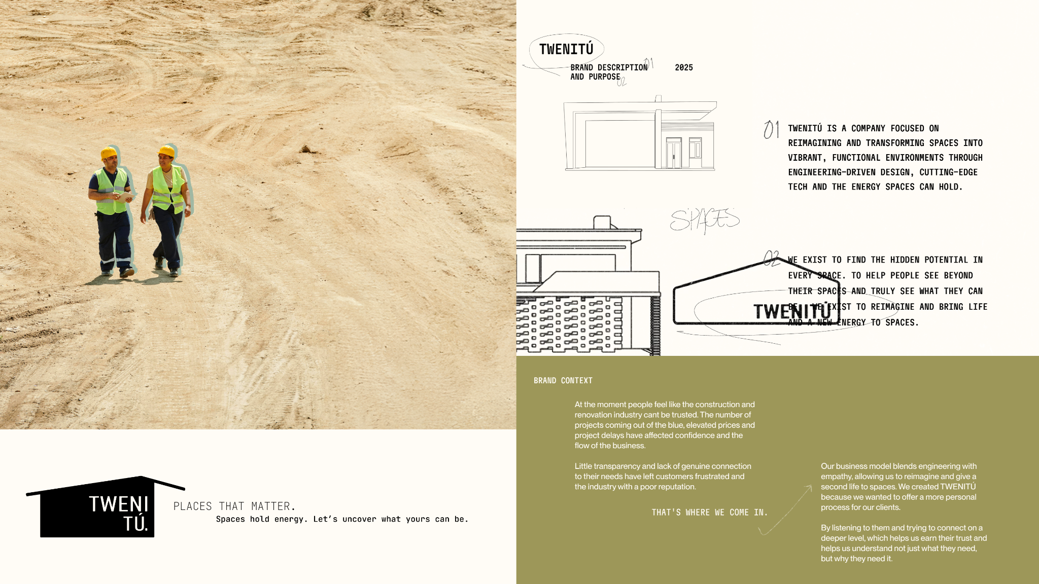*Left page:* Two construction workers walking on a sandy construction site. Bottom left corner:  
**TWENITÚ  
PLACES THAT MATTER.***Spaces hold energy. Let’s uncover what yours can be.*

*Right page:* **TWENITÚ  
  
BRAND DESCRIPTION AND PURPOSE** – 2025

TWENITÚ IS A COMPANY FOCUSED ON REIMAGINING AND TRANSFORMING SPACES INTO VIBRANT, FUNCTIONAL ENVIRONMENTS THROUGH ENGINEERING-DRIVEN DESIGN, CUTTING-EDGE TECH AND THE ENERGY SPACES CAN HOLD.

WE EXIST TO FIND THE HIDDEN POTENTIAL IN EVERY SPACE. TO HELP PEOPLE SEE BEYOND THEIR SPACES AND TRULY SEE WHAT THEY CAN BE. TO REIMAGINE AND BRING LIFE AND A NEW ENERGY TO SPACES.

**BRAND CONTEXT**   
  
At the moment people feel like the construction and renovation industry can’t be trusted. The number of projects coming out of the blue, elevated prices and project delays have affected confidence and the flow of the business.

Little transparency and lack of genuine connection to their needs have left customers frustrated and the industry with a poor reputation.

**THAT'S WHERE WE COME IN.**

Our business model blends engineering with empathy, allowing us to reimagine and give a second life to spaces. We created TWENITÚ because we wanted to offer a more personal process for our clients.

By listening to them and trying to connect on a deeper level, which helps us earn their trust and helps us understand not just what they need, but why they need it.

## Comments:

* 1
* 2
* 3

# Slide 3

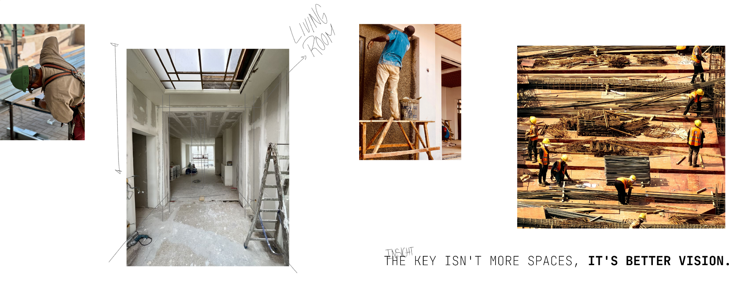Construction work and interior site images. Handwritten:

* “LIVING ROOM”
* “INSIGHT” Text:  
  THE KEY ISN’T MORE SPACES, IT’S BETTER VISION.

## Comments:

* 1
* 2
* 3

# Slide 4

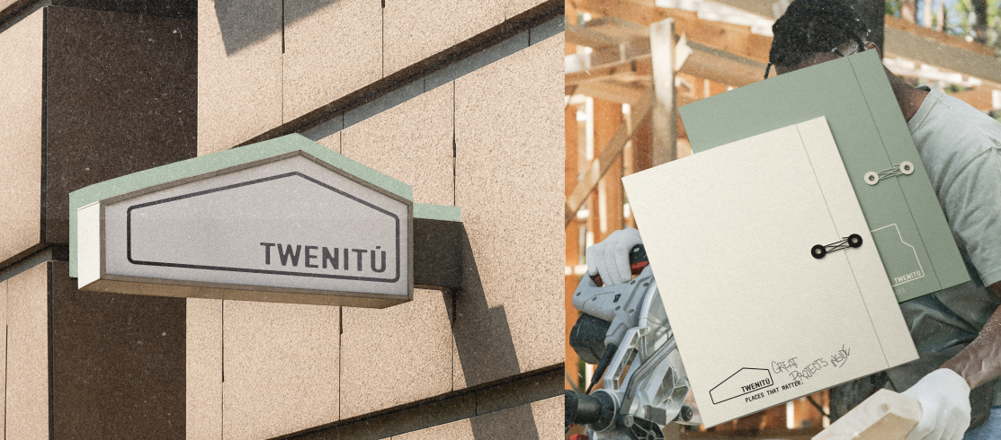Left: Wall-mounted TWENITÚ sign.  
Right: Project folders and blueprints.  
One reads: CRAFT OF PROJECTS NEXTPLACES THAT MATTER

## Comments:

* 1
* 2
* 3

# Slide 5

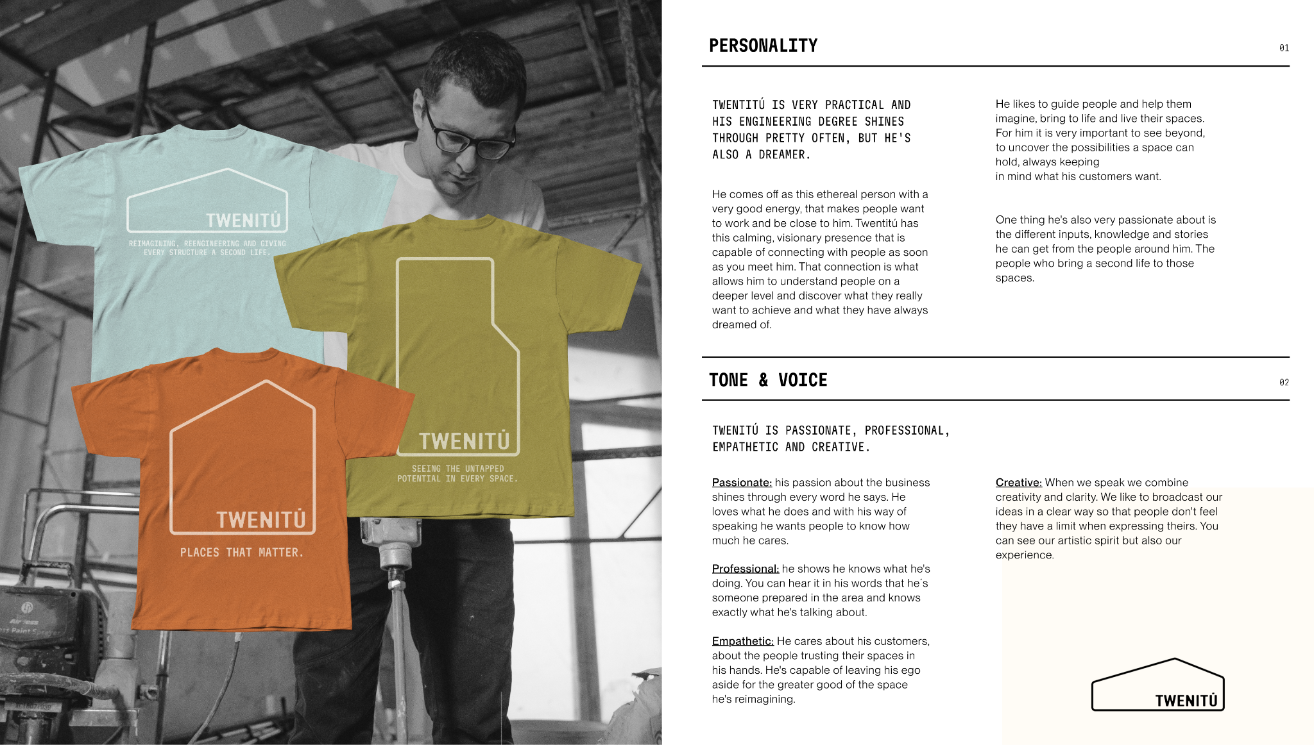Left: Branded t-shirts (blue, yellow, orange)

* Orange shirt: “TWENITÚ – PLACES THAT MATTER.”
* Yellow shirt: “TWENITÚ – SEEING THE UNTAPPED POTENTIAL IN EVERY SPACE.”
* Blue shirt: “TWENITÚ – REIMAGINING, REENGINEERING AND GIVING EVERY STRUCTURE A SECOND LIFE.”

Right: **PERSONALITY** TWENITÚ IS VERY PRACTICAL AND HIS ENGINEERING DEGREE SHINES THROUGH PRETTY OFTEN, BUT HE’S ALSO A DREAMER.

He comes off as this ethereal person with a very good energy, that makes people want to work and be close to him. Twenitú has this calming, visionary presence that is capable of connecting with people as soon as you meet him. That connection is what allows him to understand people on a deeper level and discover what they really want to achieve and what they have always dreamed of.

He likes to guide people and help them imagine, bring to life and live their spaces. For him it is very important to see beyond, to uncover the possibilities a space can hold, always keeping in mind what his customers want.

One thing he’s also very passionate about is the different inputs, knowledge and stories he can get from the people around him. The people who bring a second life to those spaces.

**TONE & VOICE** TWENITÚ IS PASSIONATE, PROFESSIONAL, EMPATHETIC AND CREATIVE.

* **Passionate:** his passion about the business shines through every word he says. He loves what he does and with his way of speaking he wants people to know how much he cares.
* **Professional:** he shows he knows what he’s doing. You can hear it in his words that he’s someone prepared in the area and knows exactly what he’s talking about.
* **Empathetic:** He cares about his customers, about the people trusting their spaces in his hands. He’s capable of leaving his ego aside for the greater good of the space he’s reimagining.
* **Creative:** When we speak we combine creativity and clarity. We like to broadcast our ideas in a clear way so that people don’t feel they have a limit when expressing theirs. You can see our artistic spirit but also our experience.

## Comments:

* 1
* 2
* 3

# Slide 6

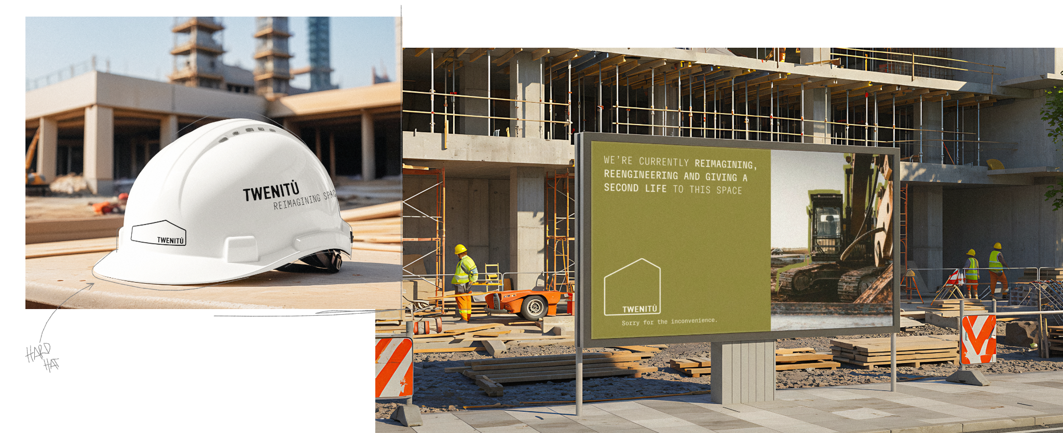Left: Hard hat with TWENITÚ logo.  
Right: Billboard at construction site. Text on billboard:  
WE’RE CURRENTLY REIMAGINING, REENGINEERING AND GIVING A SECOND LIFE TO THIS SPACETWENITÚ  
*Sorry for the inconvenience.*

## Comments:

* 1
* 2
* 3

# Slide 7

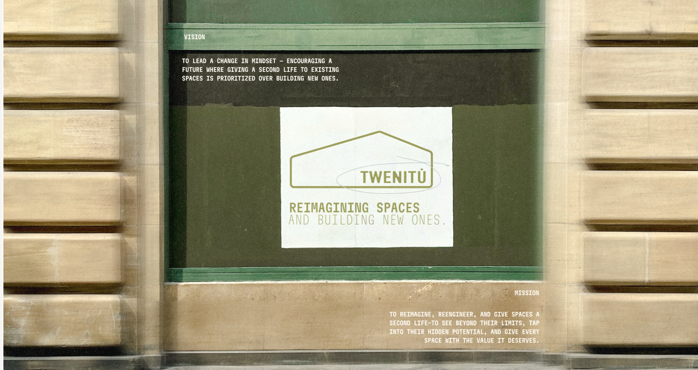**VISION** TO LEAD A CHANGE IN MINDSET – ENCOURAGING A FUTURE WHERE GIVING A SECOND LIFE TO EXISTING SPACES IS PRIORITIZED OVER BUILDING NEW ONES.

**TWENITÚ**REIMAGINING SPACES AND BUILDING NEW ONES.

**MISSION** TO REIMAGINE, REENGINEER, AND GIVE SPACES A SECOND LIFE—TO SEE BEYOND THEIR LIMITS, TAP INTO THEIR HIDDEN POTENTIAL, AND GIVE EVERY SPACE THE VALUE IT DESERVES.

## Comments:

* 1
* 2
* 3

# Slide 8

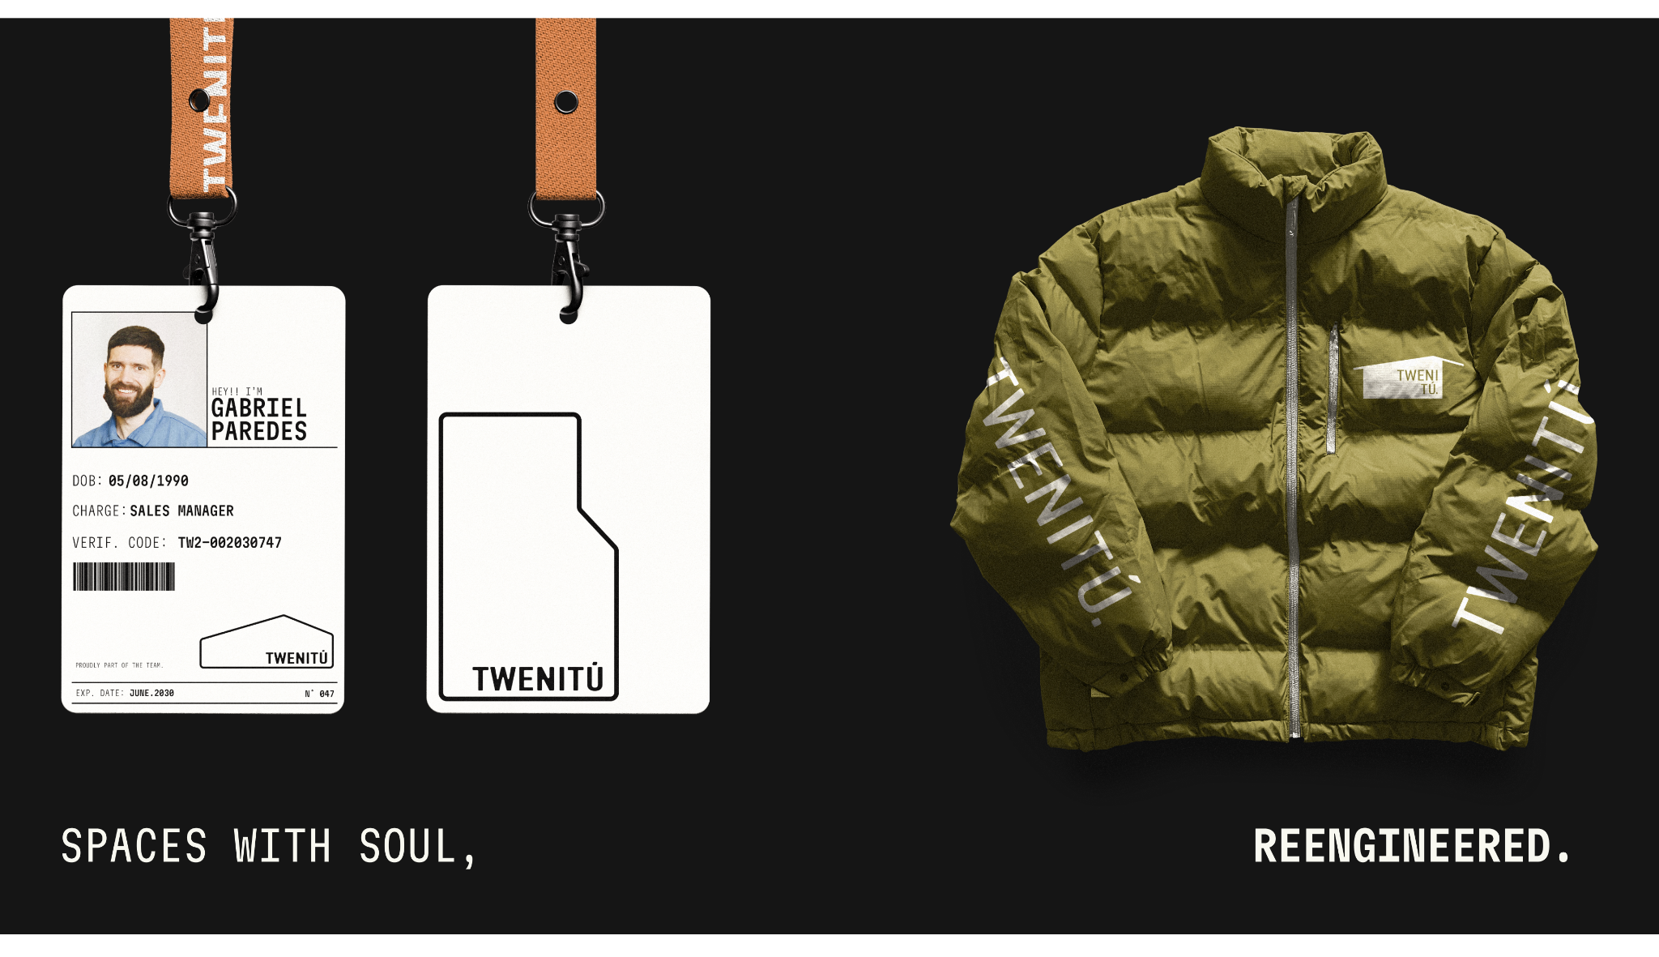Left: ID badge for Gabriel Paredes (Sales Manager) Right: TWENITÚ branded green winter jacket

Bottom text:  
SPACES WITH SOUL, REENGINEERED.

## Comments:

* 1
* 2
* 3

# Slide 9

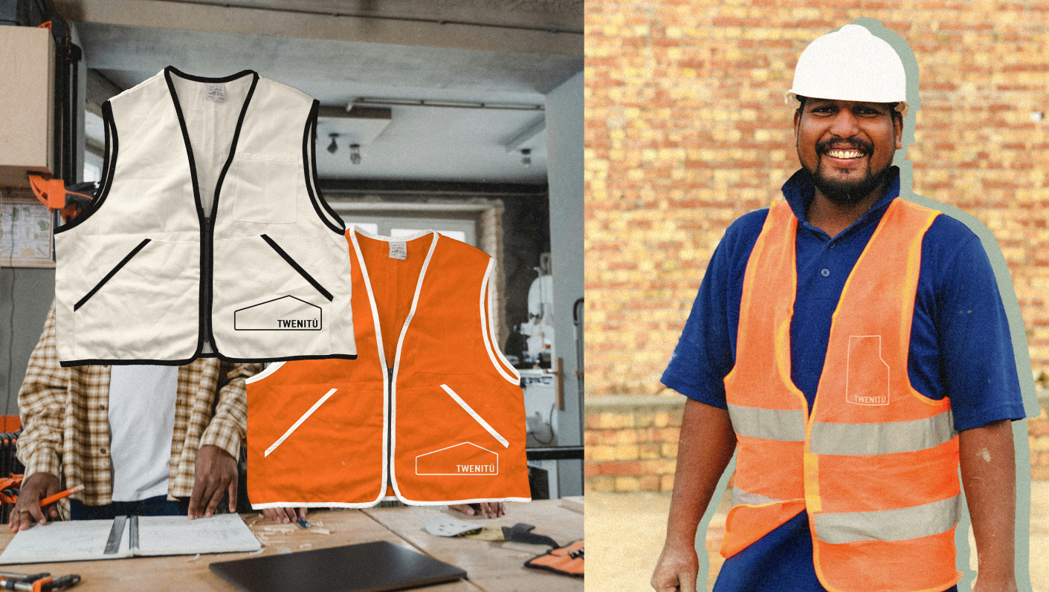Left: TWENITÚ branded white and orange safety vests  
Right: Worker smiling, wearing orange TWENITÚ vest

## Comments:

* 1
* 2
* 3

# Slide 10

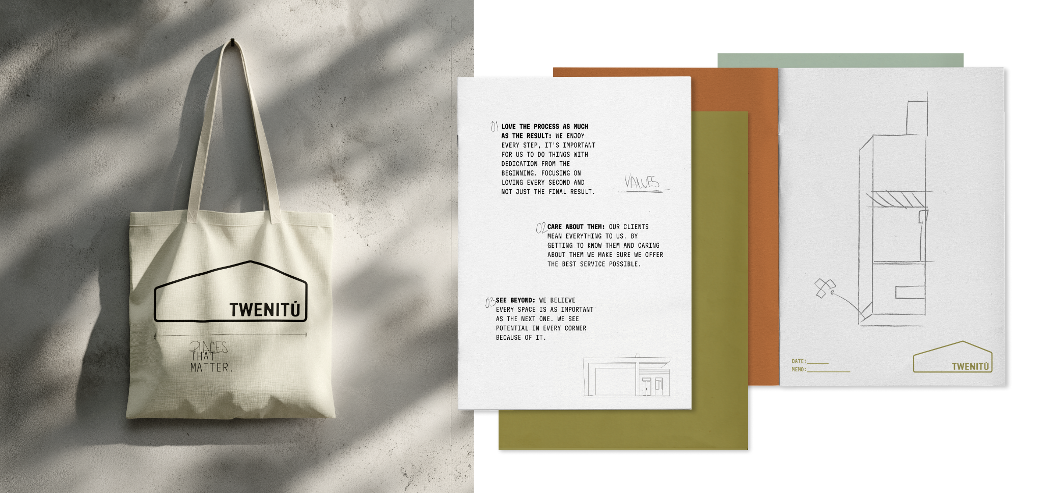Left: TWENITÚ branded tote bag with sketch that reads:  
**PLACES THAT MATTER**

Right: Values written on paper:

1. LOVE THE PROCESS AS MUCH AS THE RESULT: We enjoy every step, it’s important for us to do things with dedication from the beginning. Focusing on loving every second and not just the final result.
2. CARE ABOUT THEM: Our clients mean everything to us. By getting to know them and caring about them we make sure we offer the best service possible.
3. SEE BEYOND: We believe every space is as important as the next one. We see potential in every corner because of it.

## Comments:

* 1
* 2
* 3

# Slide 11

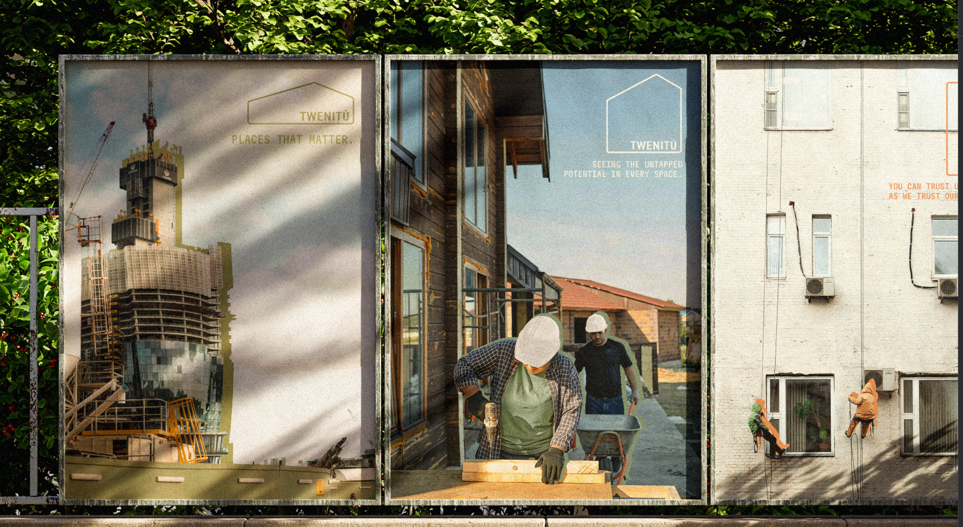Left Billboard: Skyscraper under construction. Text:  
**TWENITÚ**PLACES THAT MATTER.

Middle Billboard: Construction workers building exterior wood framing. Text:  
**TWENITÚ**SEEING THE UNTAPPED POTENTIAL IN EVERY SPACE.

Right Wall: Workers on suspended scaffold cleaning high-rise windows. Faded text on wall:  
YOU CAN TRUST US AS WE TRUST OUR OWN TEAM**…** (partially obscured)

## Comments:

* 1
* 2
* 3

# Slide 12

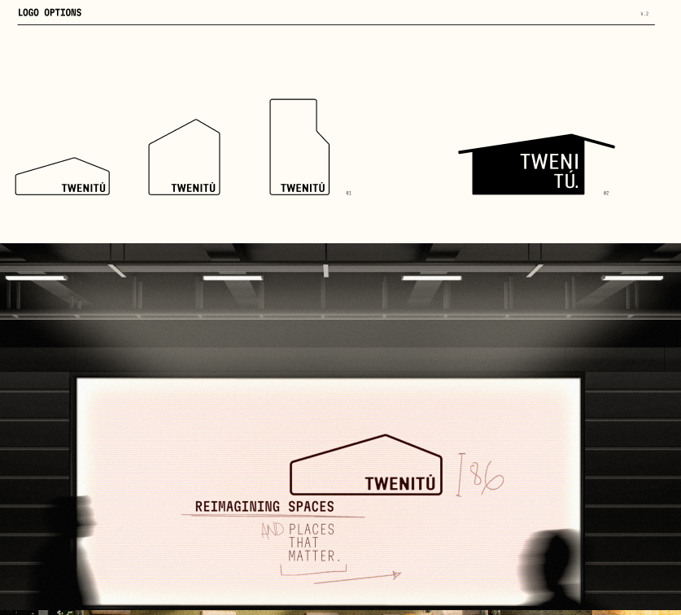Top section: **LOGO OPTIONS** Four variations of the TWENITÚ logo in different geometric outlines.

Bottom section: Large screen in a presentation room. Main text:  
**TWENITÚ  
REIMAGINING SPACES AND PLACES THAT MATTER.**(Handwritten edits and underlining present)

## Comments:

* 1
* 2
* 3

**Twenitú_Organized Text**

|| avoid

|| attention

|| okay

|| excellent

**Slide 1**

Illustration of a building. Handwritten: "REIMAGINING SPACES" Logo shape with "TWENITÚ"

**Slide 2**

*Left page:* Two construction workers walking on a sandy construction site. Bottom left corner:  
**TWENITÚ  
PLACES THAT MATTER.***Spaces hold energy. Let’s uncover what yours can be.*

*Right page:* **TWENITÚ  
  
BRAND DESCRIPTION AND PURPOSE** – 2025

TWENITÚ IS A COMPANY FOCUSED ON REIMAGINING AND TRANSFORMING SPACES INTO VIBRANT, FUNCTIONAL ENVIRONMENTS THROUGH ENGINEERING-DRIVEN DESIGN, CUTTING-EDGE TECH AND THE ENERGY SPACES CAN HOLD.

WE EXIST TO FIND THE HIDDEN POTENTIAL IN EVERY SPACE. TO HELP PEOPLE SEE BEYOND THEIR SPACES AND TRULY SEE WHAT THEY CAN BE. TO REIMAGINE AND BRING LIFE AND A NEW ENERGY TO SPACES.

**BRAND CONTEXT**   
  
At the moment people feel like the construction and renovation industry can’t be trusted. The number of projects coming out of the blue, elevated prices and project delays have affected confidence and the flow of the business.

Little transparency and lack of genuine connection to their needs have left customers frustrated and the industry with a poor reputation.

**THAT'S WHERE WE COME IN.**

Our business model blends engineering with empathy, allowing us to reimagine and give a second life to spaces. We created TWENITÚ because we wanted to offer a more personal process for our clients.

By listening to them and trying to connect on a deeper level, which helps us earn their trust and helps us understand not just what they need, but why they need it.

**Slide 3**

Construction work and interior site images. Handwritten:

* “LIVING ROOM”
* “INSIGHT” Text:  
  THE KEY ISN’T MORE SPACES, IT’S BETTER VISION.

**Slide 4**

Left: Wall-mounted TWENITÚ sign.  
Right: Project folders and blueprints.  
One reads: CRAFT OF PROJECTS NEXTPLACES THAT MATTER

**Slide 5**

Left: Branded t-shirts (blue, yellow, orange)

* Orange shirt: “TWENITÚ – PLACES THAT MATTER.”
* Yellow shirt: “TWENITÚ – SEEING THE UNTAPPED POTENTIAL IN EVERY SPACE.”
* Blue shirt: “TWENITÚ – REIMAGINING, REENGINEERING AND GIVING EVERY STRUCTURE A SECOND LIFE.”

Right: **PERSONALITY** TWENITÚ IS VERY PRACTICAL AND HIS ENGINEERING DEGREE SHINES THROUGH PRETTY OFTEN, BUT HE’S ALSO A DREAMER.

He comes off as this ethereal person with a very good energy, that makes people want to work and be close to him. Twenitú has this calming, visionary presence that is capable of connecting with people as soon as you meet him. That connection is what allows him to understand people on a deeper level and discover what they really want to achieve and what they have always dreamed of.

He likes to guide people and help them imagine, bring to life and live their spaces. For him it is very important to see beyond, to uncover the possibilities a space can hold, always keeping in mind what his customers want.

One thing he’s also very passionate about is the different inputs, knowledge and stories he can get from the people around him. The people who bring a second life to those spaces.

**TONE & VOICE** TWENITÚ IS PASSIONATE, PROFESSIONAL, EMPATHETIC AND CREATIVE.

* **Passionate:** his passion about the business shines through every word he says. He loves what he does and with his way of speaking he wants people to know how much he cares.
* **Professional:** he shows he knows what he’s doing. You can hear it in his words that he’s someone prepared in the area and knows exactly what he’s talking about.
* **Empathetic:** He cares about his customers, about the people trusting their spaces in his hands. He’s capable of leaving his ego aside for the greater good of the space he’s reimagining.
* **Creative:** When we speak we combine creativity and clarity. We like to broadcast our ideas in a clear way so that people don’t feel they have a limit when expressing theirs. You can see our artistic spirit but also our experience.

**Slide 6**

Left: Hard hat with TWENITÚ logo.  
Right: Billboard at construction site. Text on billboard:  
WE’RE CURRENTLY REIMAGINING, REENGINEERING AND GIVING A SECOND LIFE TO THIS SPACETWENITÚ  
*Sorry for the inconvenience.*

**Slide 7**

**VISION** TO LEAD A CHANGE IN MINDSET – ENCOURAGING A FUTURE WHERE GIVING A SECOND LIFE TO EXISTING SPACES IS PRIORITIZED OVER BUILDING NEW ONES.

**TWENITÚ**REIMAGINING SPACES AND BUILDING NEW ONES.

**MISSION** TO REIMAGINE, REENGINEER, AND GIVE SPACES A SECOND LIFE—TO SEE BEYOND THEIR LIMITS, TAP INTO THEIR HIDDEN POTENTIAL, AND GIVE EVERY SPACE THE VALUE IT DESERVES.

**Slide 8**

Left: ID badge for Gabriel Paredes (Sales Manager) Right: TWENITÚ branded green winter jacket

Bottom text:  
SPACES WITH SOUL, REENGINEERED.

**Slide 9**

Left: TWENITÚ branded white and orange safety vests  
Right: Worker smiling, wearing orange TWENITÚ vest

**Slide 10**

Left: TWENITÚ branded tote bag with sketch that reads:  
**PLACES THAT MATTER**

Right: Values written on paper:

1. LOVE THE PROCESS AS MUCH AS THE RESULT: We enjoy every step, it’s important for us to do things with dedication from the beginning. Focusing on loving every second and not just the final result.
2. CARE ABOUT THEM: Our clients mean everything to us. By getting to know them and caring about them we make sure we offer the best service possible.
3. SEE BEYOND: We believe every space is as important as the next one. We see potential in every corner because of it.

**Slide 11**

Left Billboard: Skyscraper under construction. Text:  
**TWENITÚ**PLACES THAT MATTER.

Middle Billboard: Construction workers building exterior wood framing. Text:  
**TWENITÚ**SEEING THE UNTAPPED POTENTIAL IN EVERY SPACE.

Right Wall: Workers on suspended scaffold cleaning high-rise windows. Faded text on wall:  
YOU CAN TRUST US AS WE TRUST OUR OWN TEAM**…** (partially obscured)

**Slide 12**

Top section: **LOGO OPTIONS** Four variations of the TWENITÚ logo in different geometric outlines.

Bottom section: Large screen in a presentation room. Main text:  
**TWENITÚ  
REIMAGINING SPACES AND PLACES THAT MATTER.**(Handwritten edits and underlining present)

**Banana Creative_Brand Adjustment**

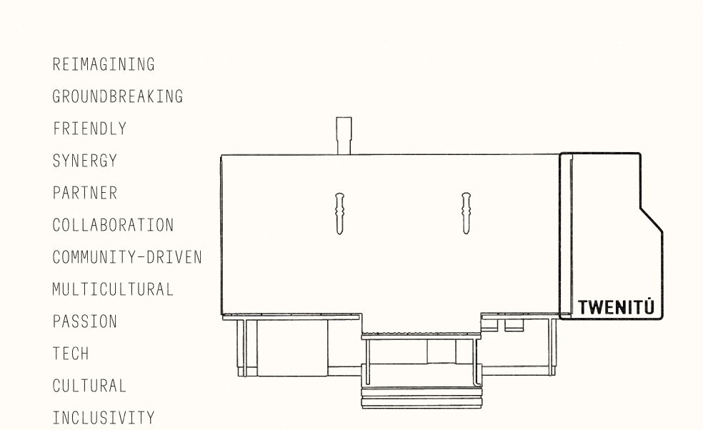

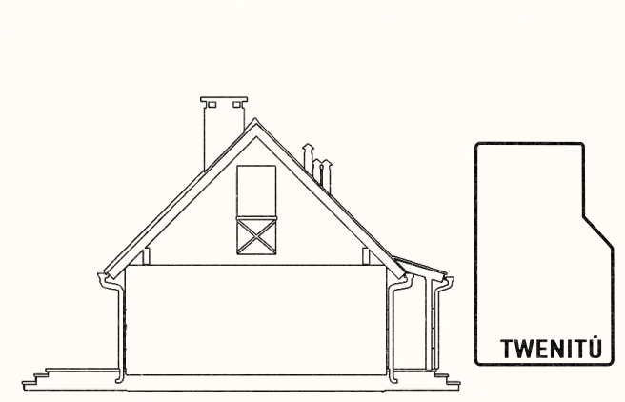

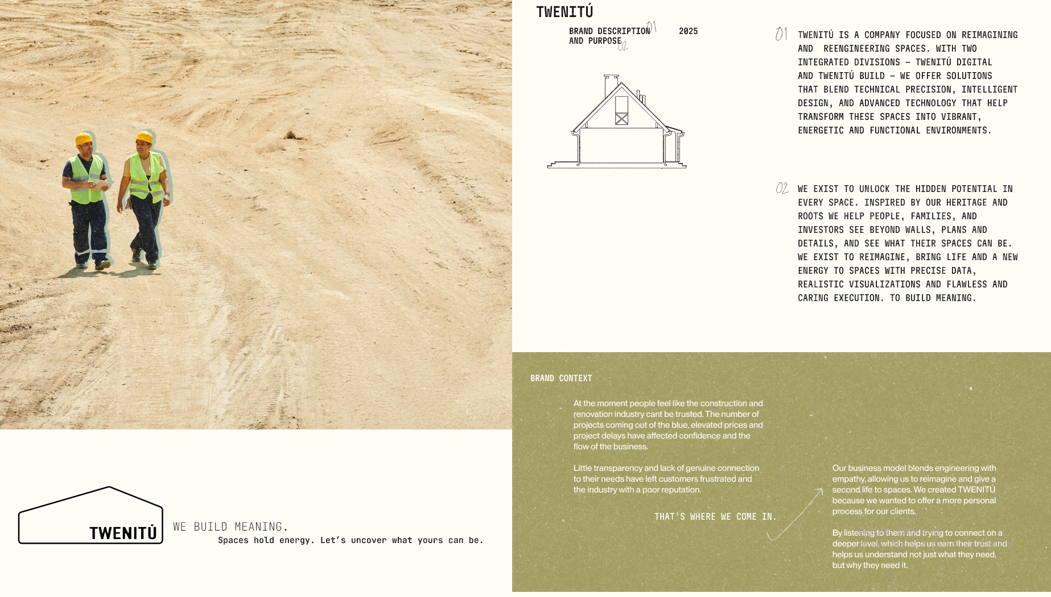

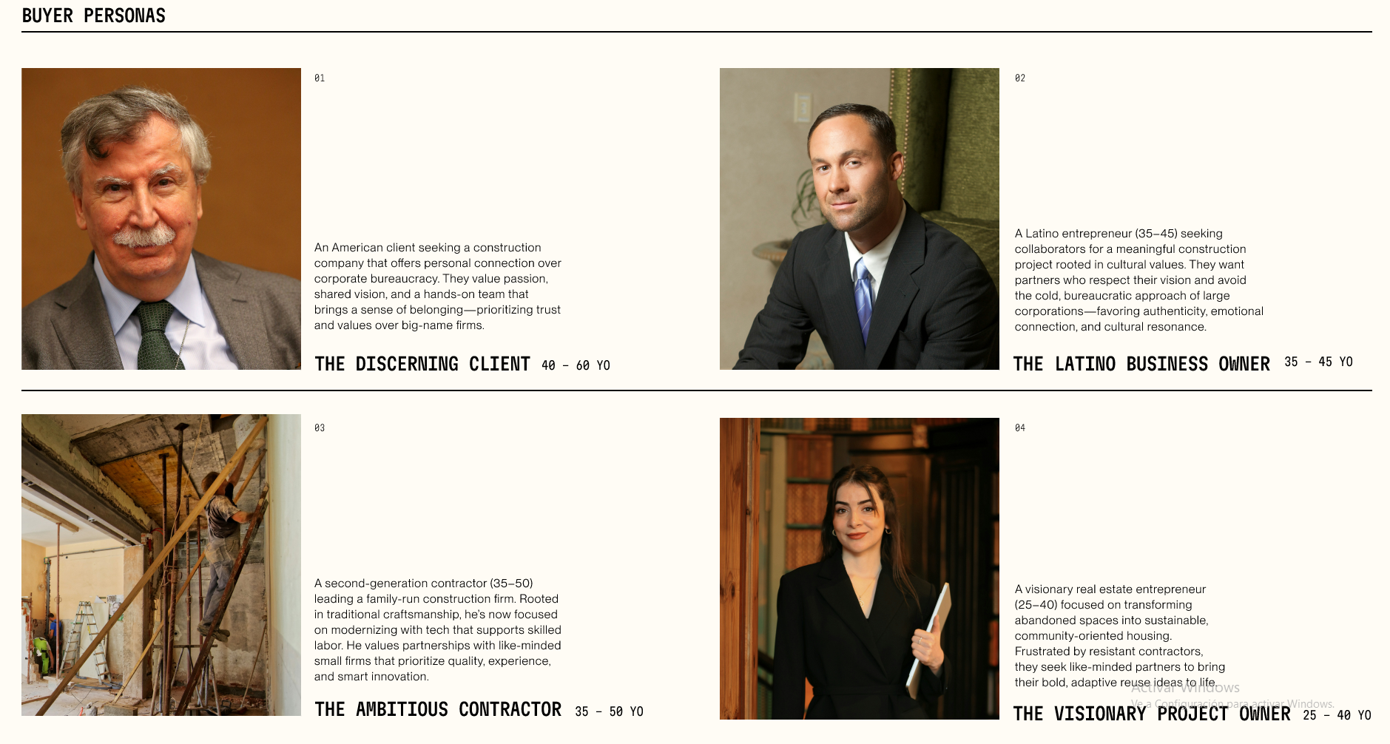

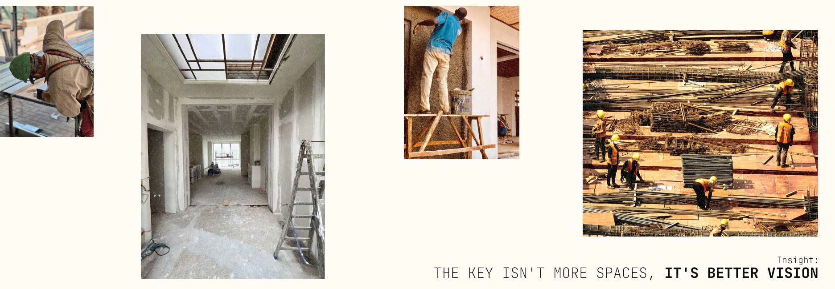

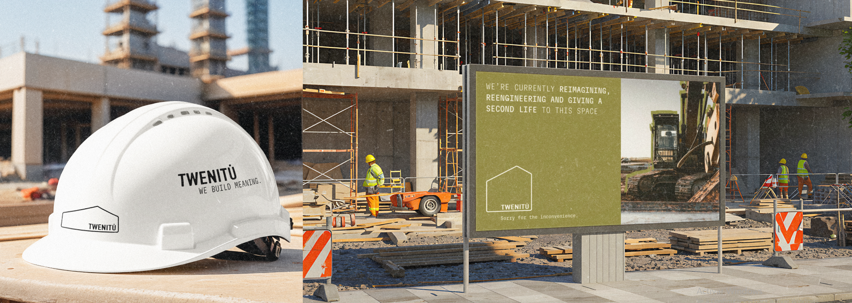

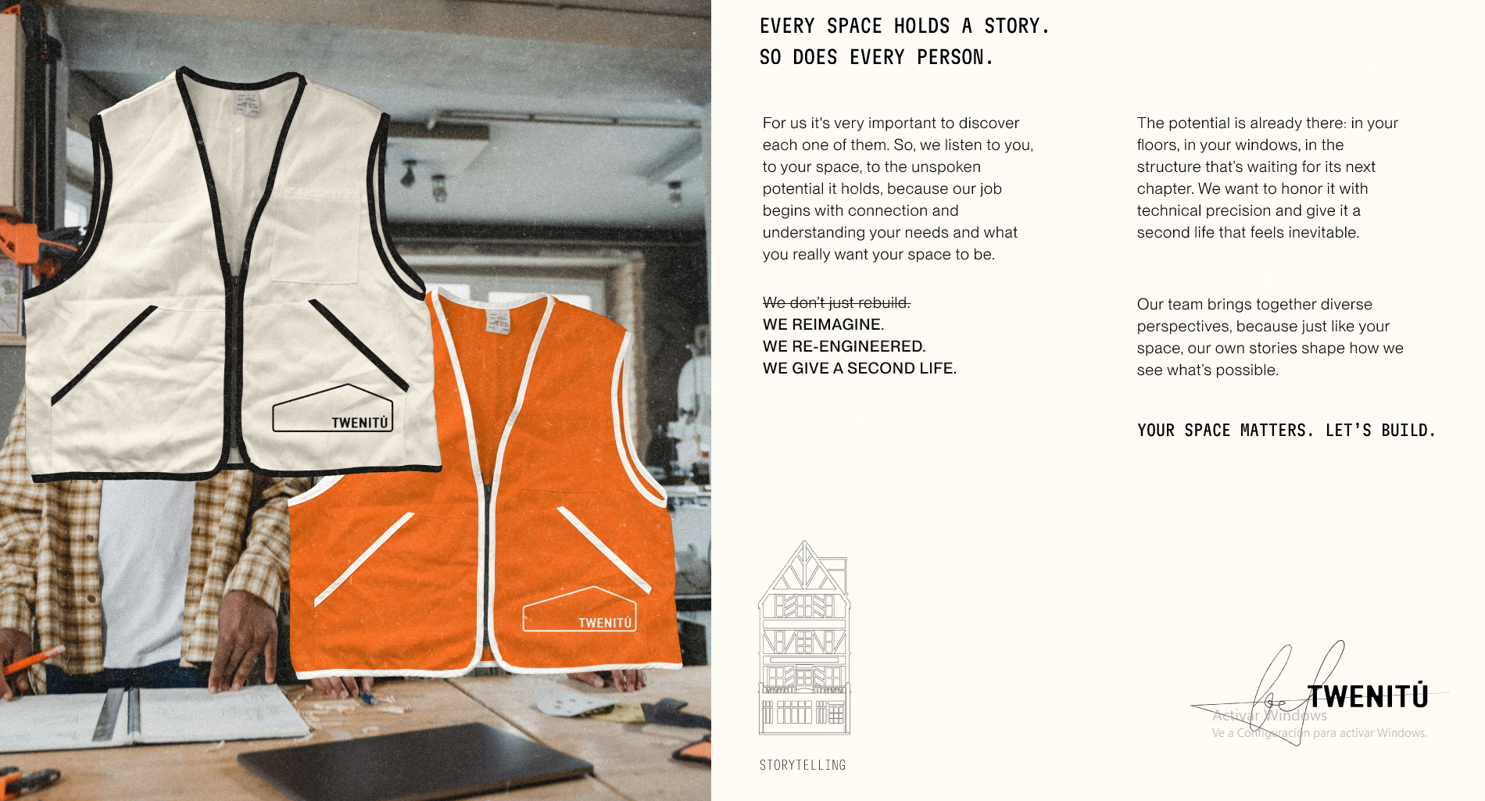

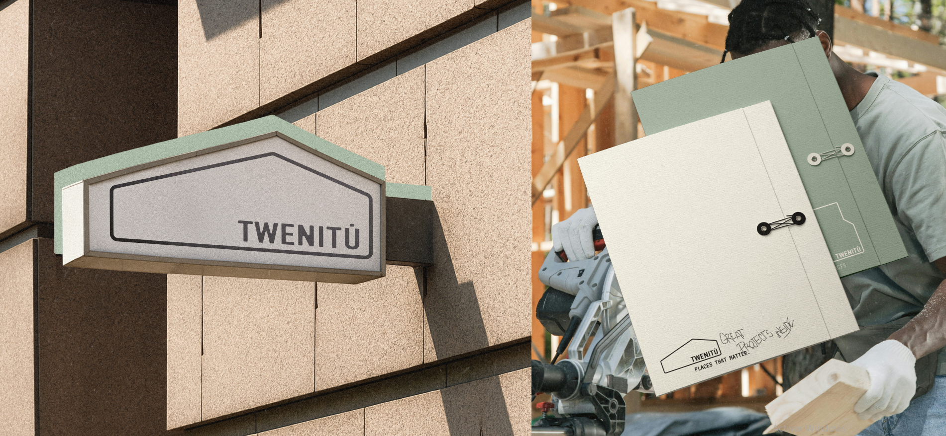

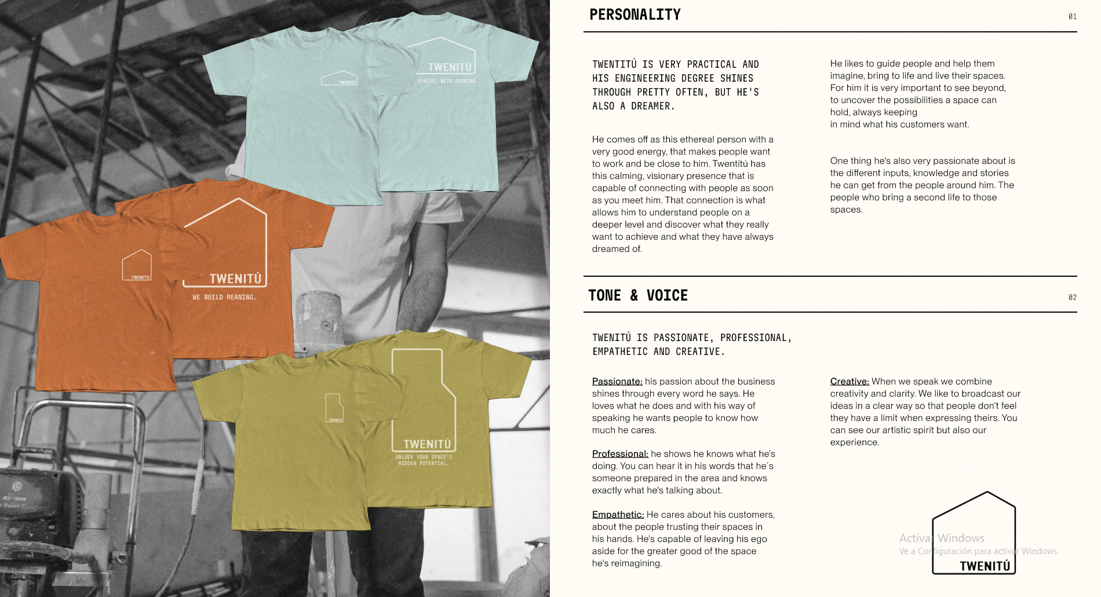

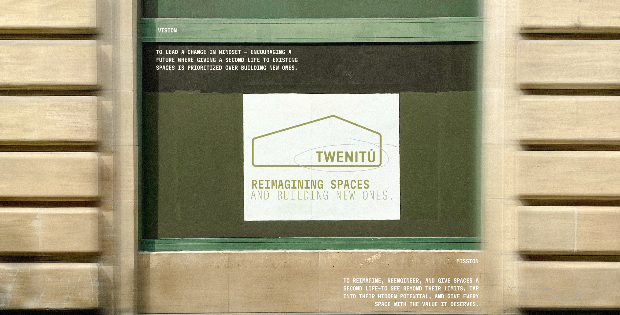

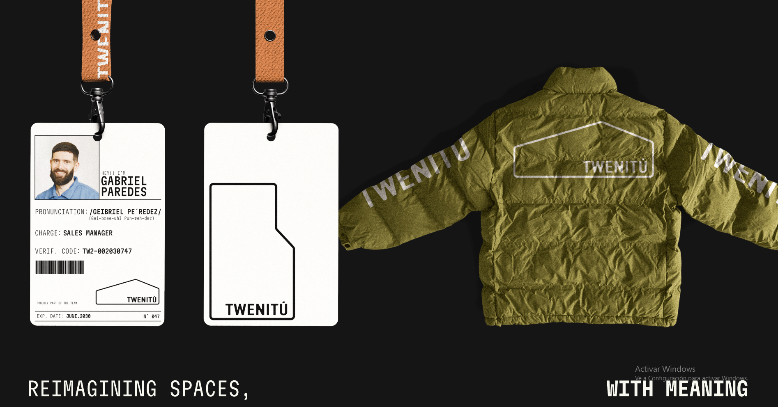

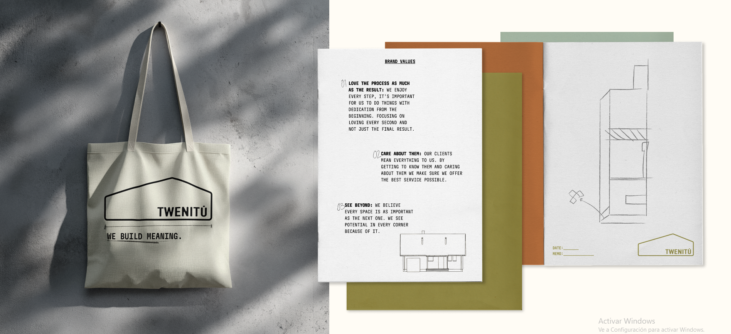

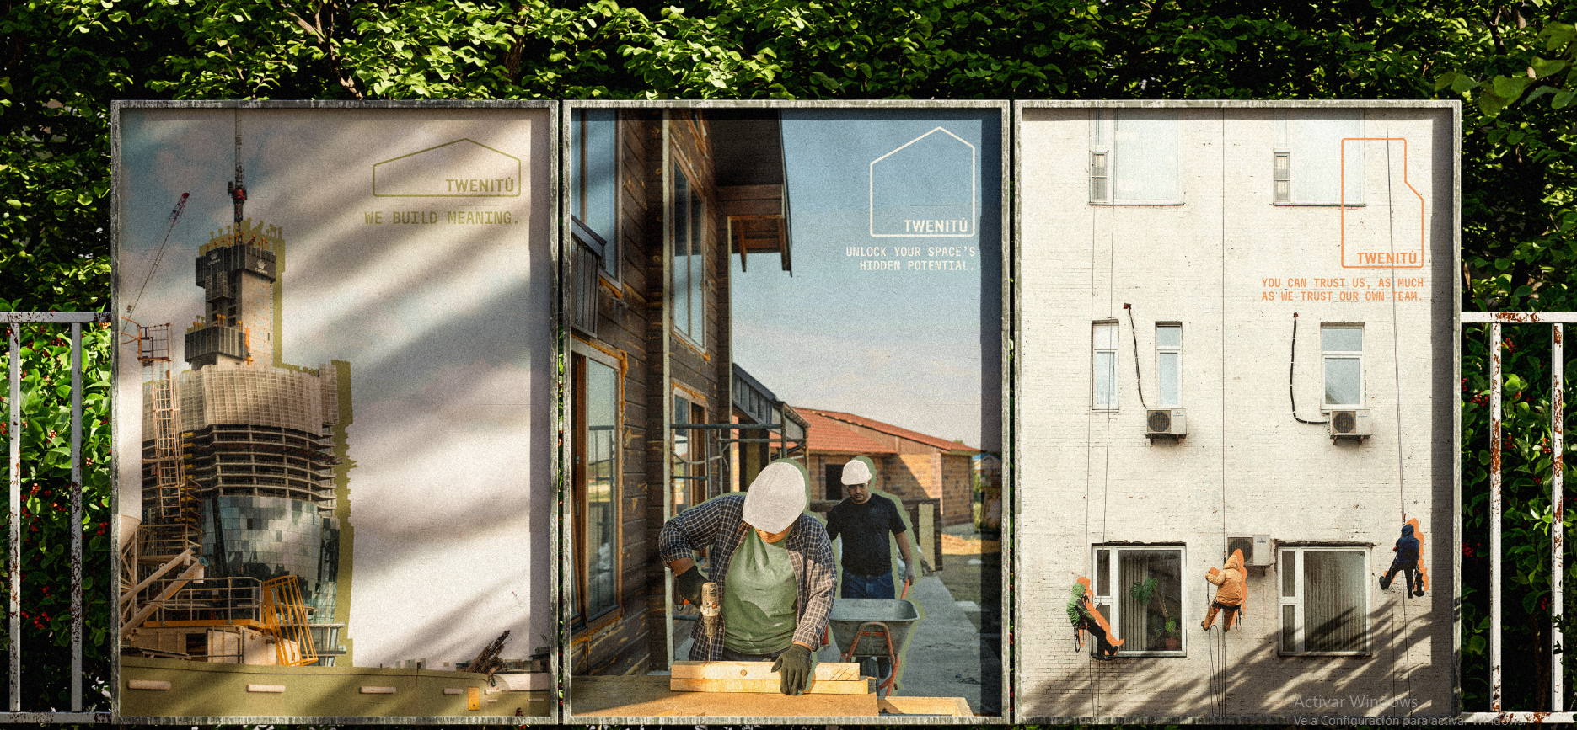

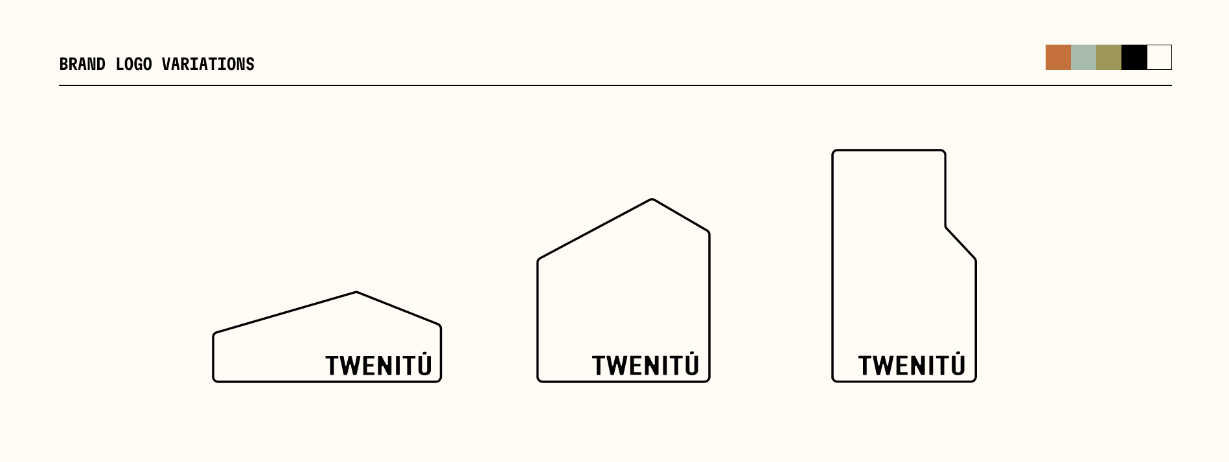

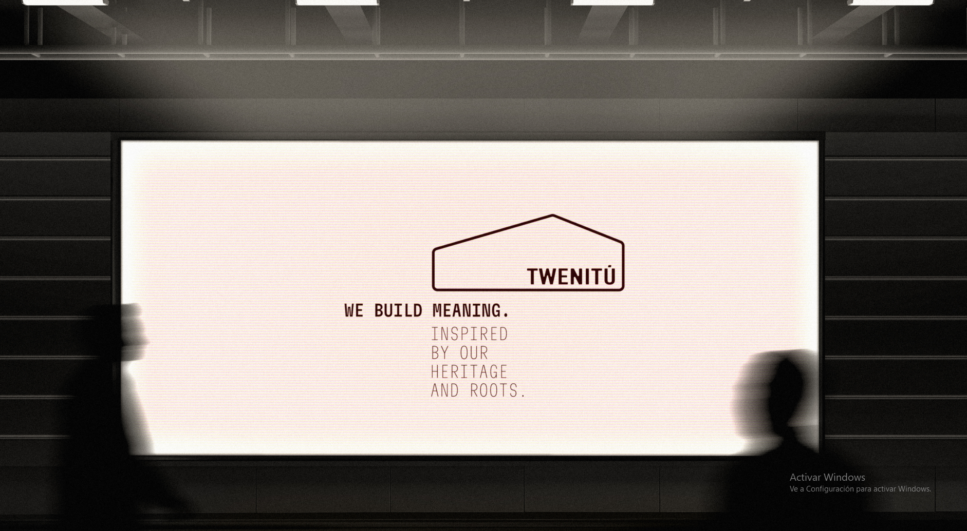

**Banana Creative_Atterrizaje**

# Aterrizaje



Gabriel Paredes

# Aterrizaje

Con base en la propuesta planteada favor de llenar el siguiente formulario.

# 1. Proyecto

Twenitú

# 2. ¿Cuál es tu opinión sobre el insight, el propósito y contexto de la marca?

Unfortunately we don’t feel connected to the narrative exposed by you guys. The reason is that we feel it is slightly generic. It doesn’t communicate to the reader what’s the essence of our company.   
  
We don’t mean to offend the work presented.  
  
Here we will be attaching a brief brand that we can use to reshape or edit the presented by you all:  
  
**Brand Description – Projecto Twenitú (2025)**Twenitú is a company founded on solid foundations: purpose, creativity, and vision. It was born to reimagine spaces and reengineer their essential value—not only functional or expressive, but energetic and symbolic.  
  
With two integrated divisions — Twenitú Digital and Twenitú Build — we offer solutions that blend technical precision, intelligent design, and advanced technology. Whether capturing a digital model with 3D scanners or physically reimagining a space, we transform the way people perceive, design, and build.  
  
We are engineers of transformation. Of the visible… and of what is yet to be seen.

**Purpose Statement – Why do we exist?**

We exist to unlock the hidden potential in every space.

Because we believe that every wall, every plan, every detail holds a story waiting to be retold—with clarity, intention, and purpose.

Inspired by our heritage, our roots, and our love for building, we help people, families, and investors see beyond physical limits. We give them tools to make better decisions—with precise data, realistic visualizations, and flawless execution.

We are Twenitú. We reimagine spaces. We build meaning.

# 3. ¿Cuál es tu opinión sobre las frases, tagline y descripción de la marca?

* **REIMAGINING SPACES.**   
  We like this since it mentions two important keywords we would like to use in our narrative.
* **PLACES THAT MATTER.**   
  We don’t agree with using the word “Places” also we don’t feel connected with the phrase in general.
* **SEEING THE UNTAPPED POTENTIAL IN EVERY SPACE.**    
  From our point of view, the word Untapped is not commonly used to relate with the Construction Field. Nonetheless, we like the word “Potential” and “Space”
* **REIMAGINING, REENGINEERING AND GIVING EVERY STRUCTURE A SECOND LIFE.**   
  When reading the phrase, it doesn’t have a continuity or flow to make it sticky. It seems to be long and also slightly confusing to pronounce and/or to read.
* **SPACES WITH SOUL. REENGINEERED.**We don’t understand this catch phrase underneath the ID Card. The same with the Coat/Jacket. Even though the idea of the coat for the winter is cool, those are not the common coats.
* **REIMAGINING SPACES AND PLACES THAT MATTER.** (versión combinada utilizada como cierre visual en la presentación)  
  When reading the phrase, it doesn’t have a continuity or flow to make it sticky.

# 4. ¿Tienes algún comentario sobre las animaciones de la marca?

In the videocall we mentioned about adapting the shape of the House you guys show under animation to a House that represents more the style of houses that are popular here in Chicago. The Chicago Workers Cottage to be more specific.

# 5. Comentarios sobre el logo aprobado

We have chosen the Logo Option #01. We would like to see the word Twenitú separated under this concept. Meaning, seeing first Tweni and then Tú underneath.

# 6. ¿Tienes algún comentario sobre la paleta de colores?

We like the colors. We also think that these colors are part of the trend and we might be slightly afraid that these colors will be meaningful after the trend. We would like to have your feedback about that. We understand we might be wrong

# 7. ¿Quisieras comentar algo sobre las tipografías?

We like the main typography. What I still don't catch is the Handwritten traces or words.

# 8. Comentarios sobre los aplicativos presentados Ajustes en específico o generales en cuanto a los aplicativos a desarrollar.

Regarding the Application Packs,   
  
**ID Card**

* Removing the birth date shown for the employee.
* Add International Phonetic Alphabet (IPA) to each name.  
  Example:  
  Gabriel (/ˈɡeɪbriəl/ GAY-bree-uhl)[ **T-Shirt**
* The front of the T-Shirt should have the logo in a small version in the Left Pocket of the T-Shirt. The Back of the T-Shirt will show the variations of the logo taking in consideration that the T-Shirt or Polo should be worn tucked in by the employee. **Security Vest**
* **Look Good.  
    
  Envelopes**
* **Look Great.  
    
   Signage**
* **Look Great.  
    
  Hard Hat**
* **Look Great.  
    
  Grocery Bag**
* Look great.  
    
  **Coat/Jacket**
* Look good, but the style of the coat is not correct.

# 9. ¿Tienes algún comentario con relación a los elementos gráficos propuestos?

No comments for the Graphic Elements shown.

# 10. Comentarios adicionales De tener todos los ajustes especificados en este formulario avanzariamos con la propuesta final.

**Ben Cline_Meeting Agenda**

## 

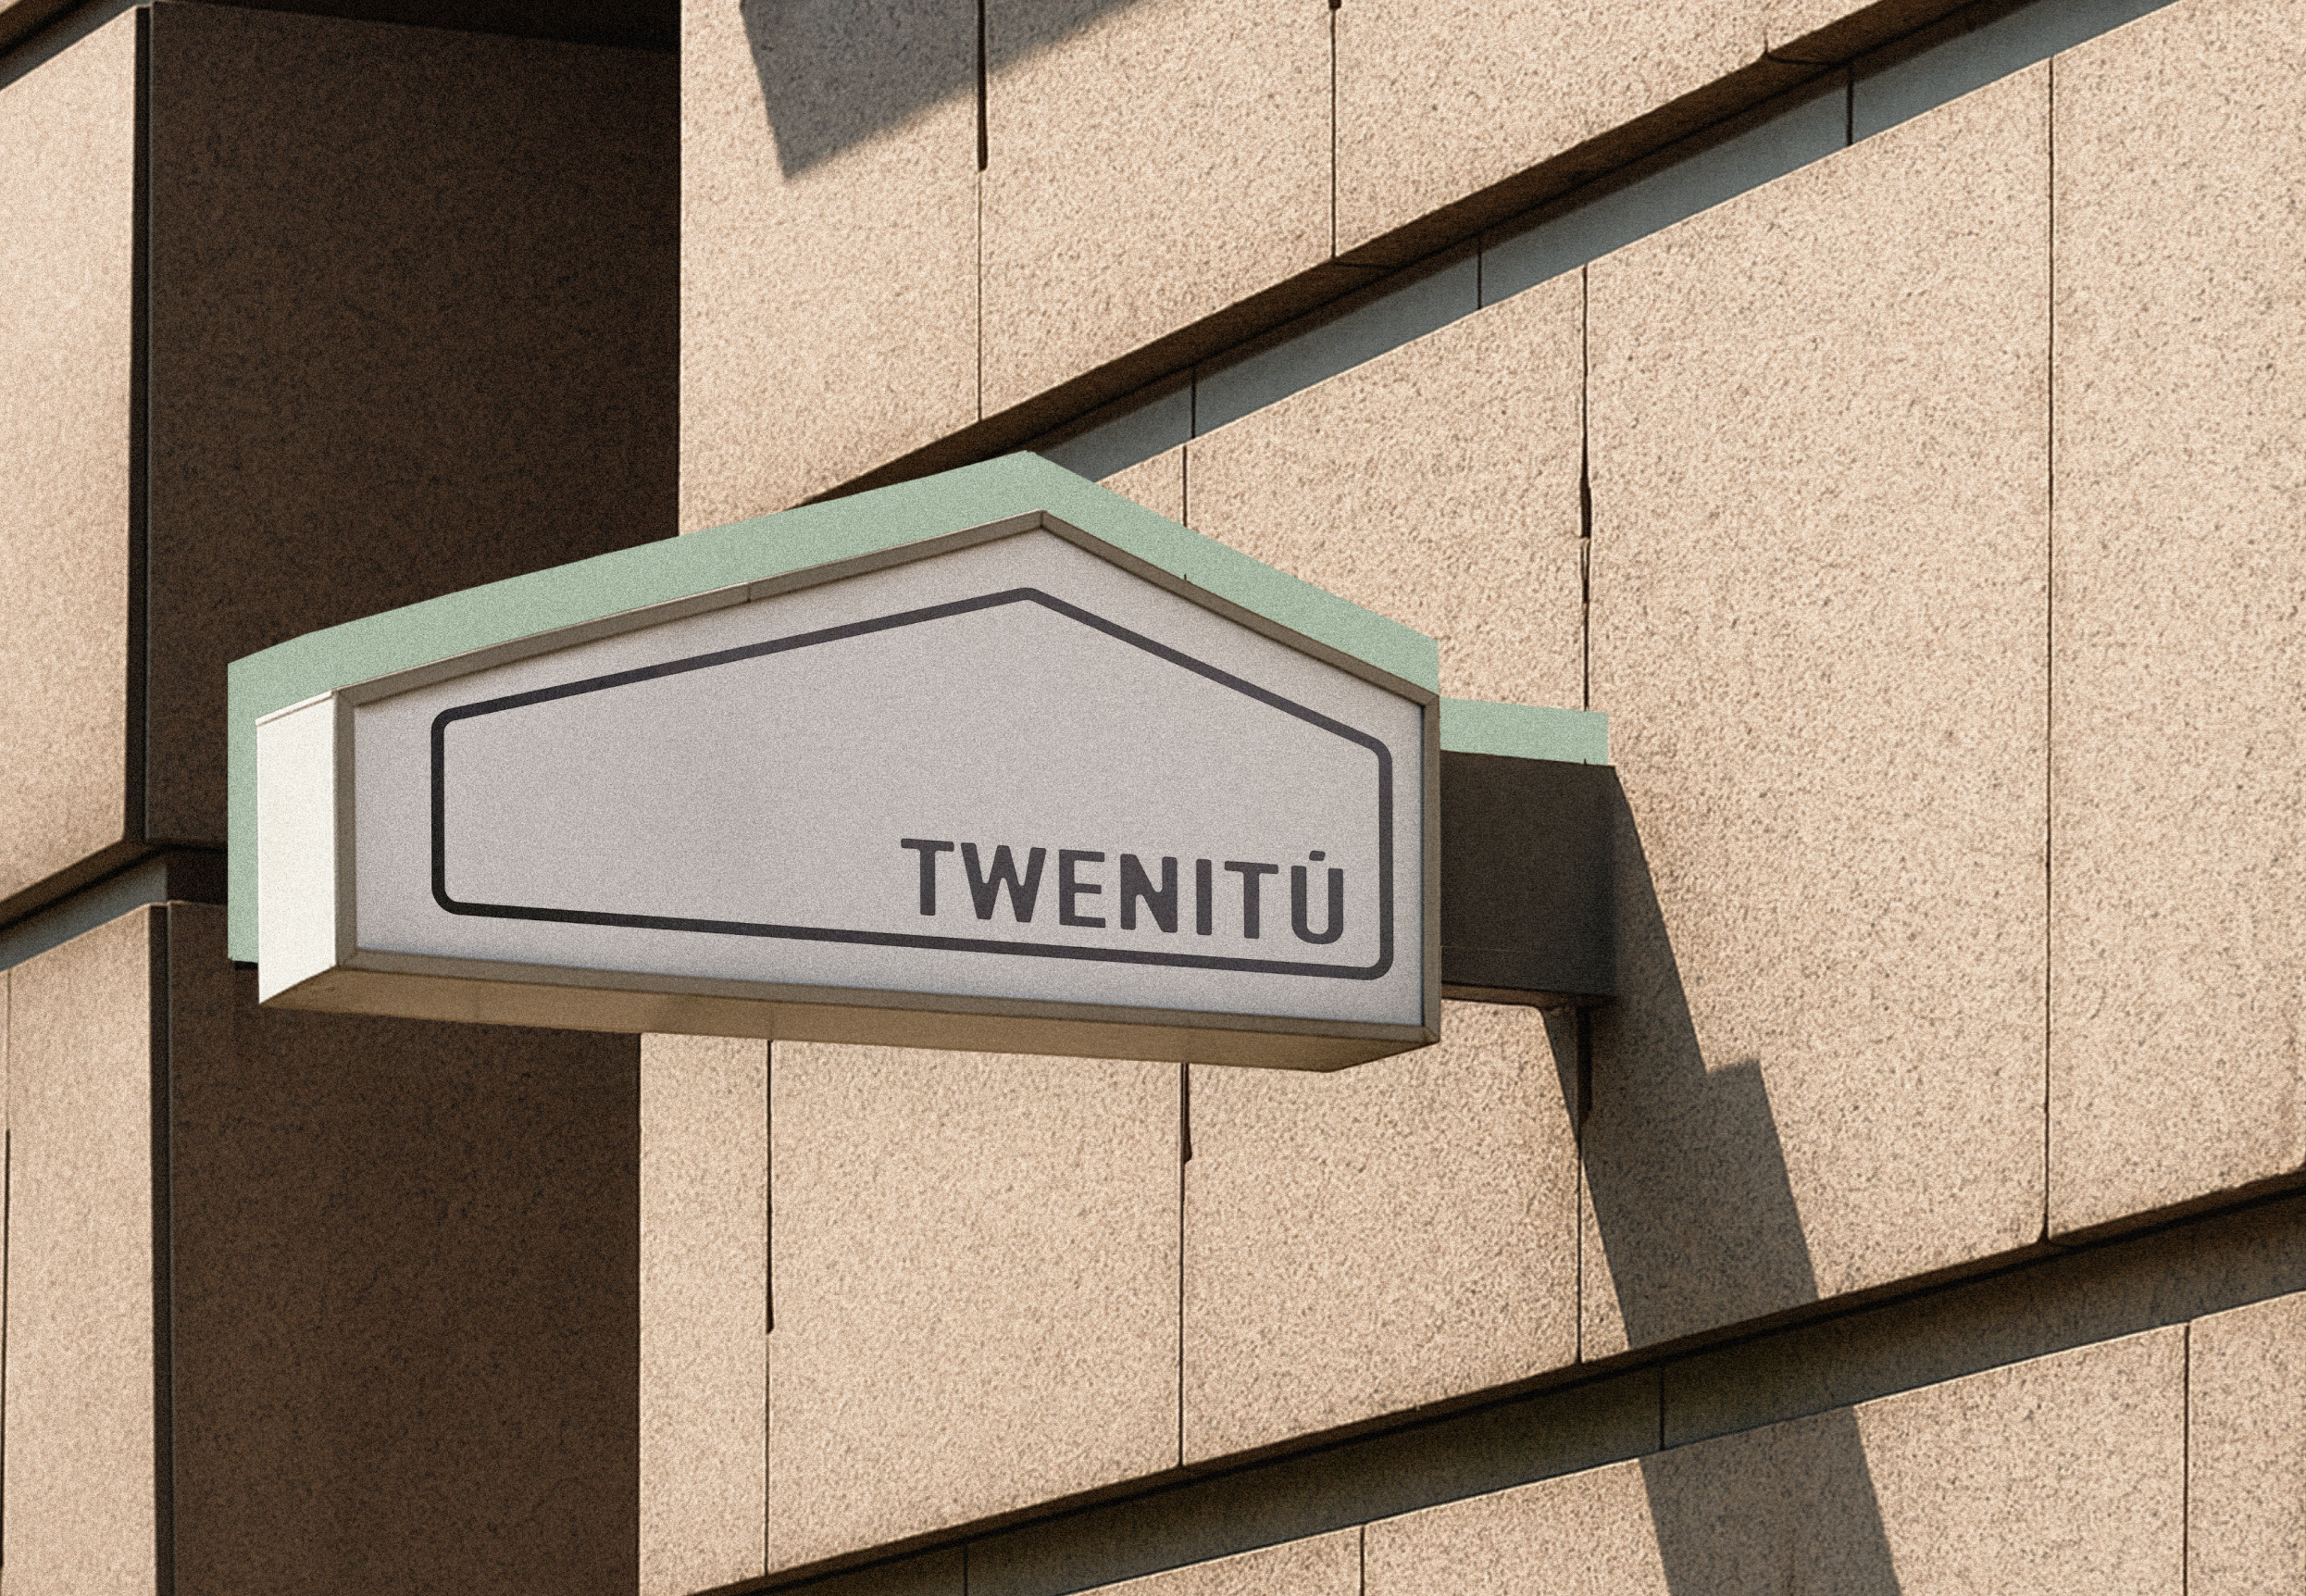

PROJECTO TWENITÚ

DIGITAL & BUILD

**📅 Meeting Agenda with Ben Cline  
Date:** 17 Jun 2025  
**Time:** 11:00 AM CST  
**Invitees:** Ben Cline  
**Duration:** ~30–40 minutes

### **1. Welcome & Introduction (3 min)**

* General Background
* Background on Projecto Twenitú
* Overview of the Build and Digital Divisions

### **2. Why Twenitú Digital? (3 min)**

* Brief description of the need for digital tools in real estate
* Intro to the three core products: TwinScan, TwinModel, and TwinShow
* Positioning: Twenitú as a "Space Intelligence Partner" for agents & developers  
    
  **3. Product Presentations & Demonstrations (20 min)**

#### 🔵 TwinScan – Reality Capture & Immersive Visualization (5 min)

* Live 3D walkthrough and tags demo
* Highlight spatial context & embedded tag value

#### 🟧 TwinModel – Data Intelligence from Design (5–7 min)

* PDF dashboard walkthrough
* Show finish schedules, measurements, square footages
* Upcoming Power BI interactivity
* Emphasize potential for investor presentations, remodel planning

#### 🟩 TwinShow – Visual Storytelling & Sales Enablement (7–8 min)

* Play video render (cinematic walkthrough)
* Showcase toggles or stills for finishes/furniture
* Show how it ties into listing decks, investor previews
* Phrase to use: “This sells the story before the space exists.”

### **4. Strategic Use Cases for Ben (5 min)**

* Attracting investors with stronger visuals
* Marketing unfinished or pre-renovated listings
* Increasing perceived value through smart presentation
* Discuss a test run or pilot example (e.g., upcoming property)

### **5. Q&A & Next Steps (5 min)**

* Address questions
* Offer to co-brand visuals for Ben's listings
* Schedule follow-up to test a TwinScan or TwinShow package

## **🔵 TwinScan: Reality Capture & Immersive Visualization**

**Overview:**TwinScan is our advanced reality capture service that produces an immersive 3D digital twin of any space. It enables interactive walkthroughs, real-time collaboration, and embedded tags with itemized information.

**Key Features:**

* Matterport 3D scan with full Dollhouse and Floorplan views
* Walkthrough functionality for remote exploration
* Interactive Tags embedded with material specs, fixture details, or custom notes
* As-built reference for design, inspection, and marketing

**Use Cases for Real Estate:**

| **Scenario** | **Application** |
| --- | --- |
| Pre-listing walkthrough | Provide agents with digital access to prep marketing or design packages |
| Remote buyers or investors | Enable out-of-state clients to explore spaces interactively |
| Virtual open houses | Share immersive tours with potential buyers without requiring site visits |
| Renovation documentation | Capture as-is condition for future remodeling projects |
| Developer client review | Walk stakeholders through buildout progress or concepts |

**Client Benefit:**

"Capture the space once, reuse it infinitely — for marketing, design, or permits."

## **🟧 TwinModel: Data Intelligence from Design**

**Overview:**TwinModel transforms 3D scans and design plans into data-rich dashboards. This is the intelligence layer of our system, where quantities, materials, and areas become measurable and visual.

**Current Format:**

* PDF dashboard extracted from Revit + Power BI visuals
* Shows square footages, finish schedules, and material breakdowns

**Upcoming (In Development):**

* Interactive Power BI dashboard
* Area-based cost overlays and renovation scenario comparison

**Use Cases for Real Estate & Developers:**

| Scenario | Application |
| --- | --- |
| Project budgeting | Provide accurate SF and quantity takeoffs from the model |
| ROI presentation | Show material use and finish level for cost analysis to investors |
| Design option comparison | Display alternate layouts or finish options with measurable metrics |
| Permit documentation support | Provide area-based breakdowns for scope validation |
| Renovation strategy planning | Use quantifiable data to guide finish upgrades or layout modifications |

**Client Benefit:**

"Design with data. Sell with certainty."

## **🟩 TwinShow: Visual Storytelling & Sales Enablement**

**Overview:**TwinShow is our visual marketing product, designed to help clients communicate the potential of a space. Through cinematic video renders, styled photos, and interactive mockups, we bring future spaces to life.

**Key Features:**

* Rendered walkthrough videos
* Still renders and styled images
* Toggle mockups (e.g., finish options, furniture layouts)

**Use Cases for Real Estate:**

| Scenario | Application |
| --- | --- |
| Pre-sale visualization | Help buyers picture the final result before buildout |
| Off-market listings | Give a premium presentation edge for investor decks or private showings |
| Staging alternative | Present furnished options without physical staging |
| Customization previews | Let clients toggle finish options during design selection process |
| Developer pitch decks | Use visual assets to communicate design vision and unit potential |

**Client Benefit:**

"Sell the story before the space exists."

## **💲 Pricing Overview**

| **Product** | **Format/Deliverables** | **Price (Starting At)** |
| --- | --- | --- |
| **TwinScan** | **3D Matterport Scan + Interactive Tags** | **$ 0.00 per property/ SF / Others** |
| **TwinModel** | **PDF Dashboard (Revit + Power BI data)** | **$ 0.00 – $ 0.00 per LOD (Level of Detail)** |
| **TwinShow** | **Rendered Video + Still Renders + Toggle Views** | **$ 0.00 – $ 0.00 per set** |

**Together, TwinScan, TwinModel, and TwinShow give real estate professionals, developers, and investors the digital tools they need to reimagine, present, and build smarter.**

# AS-IS DASHBOARD

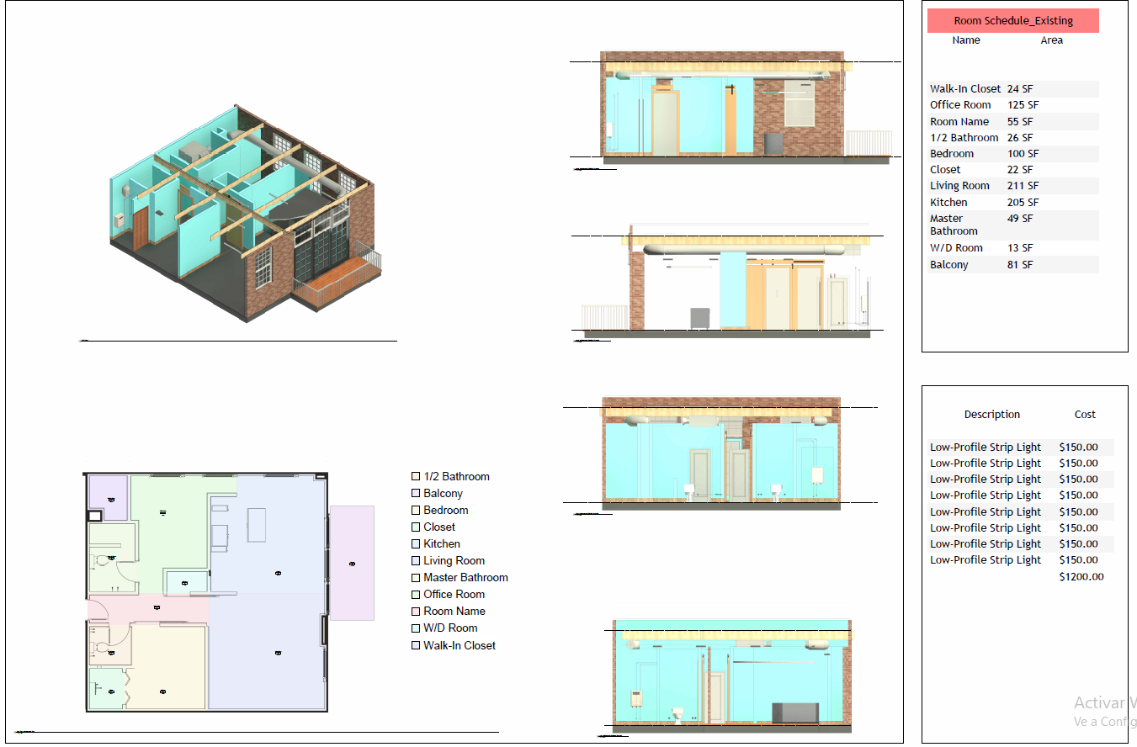

# PROPOSAL DASHBOARD

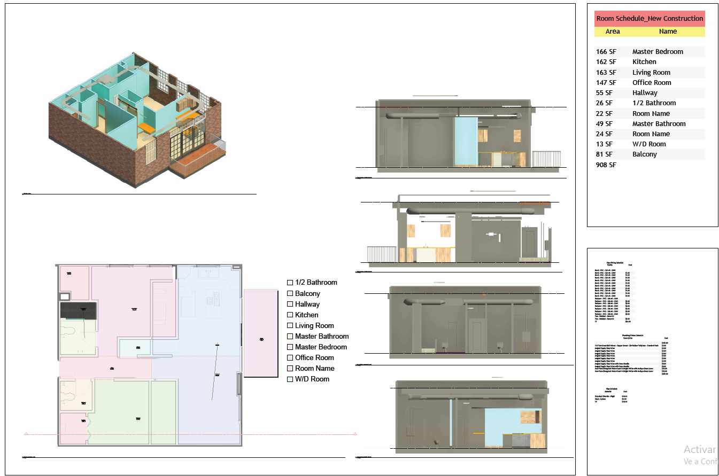

**Assitant Conversations**

### **1. Establish a Base Metric for MEP Estimation**

The key is to develop a set of baseline assumptions based on the **type of space** within each unit. This can be broken down into **space types** like **Office Spaces**, **Cubicles**, **Warehouses**, **Common Areas**, **Corridors**, and **Mechanical Rooms**. Each of these space types will have a different density of MEP elements.

#### Example of Baseline MEP Density:

| **Space Type** | **Typical MEP Density** | **Elements to Consider** | **LOD Range** |
| --- | --- | --- | --- |
| Office Space | High | HVAC ducts, lighting, electrical outlets, fire sprinklers, plumbing fixtures | 300-400 |
| Cubicles | Medium | Electrical outlets, data points, sprinkler heads, small HVAC ducts | 300 |
| Warehouse | Low | Large ducts, basic lighting, fire suppression systems, minimal plumbing | 300-350 |
| Common Areas | Medium | Lighting, HVAC, fire suppression, emergency exits | 300-400 |
| Corridors | Low | Emergency lighting, exit signs, sprinkler heads, minimal HVAC | 200-300 |
| Mechanical Rooms | High | Piping, control panels, electrical panels, HVAC equipment | 400-500 |

### **2. Use Historical Data and Industry Standards**

* **Historical Data:** If you have data from previous projects, use this to establish average counts for MEP elements based on square footage and usage type.
* **Industry Standards:** Use standards like **ASHRAE**, **NFPA**, and **SMACNA** to estimate MEP element density based on building function.

### **3. Factor in Space Complexity and Building Age**

* **Newer Buildings:** Typically have more integrated and compact MEP systems.
* **Older Buildings:** May have more complex retrofitting needs, requiring additional MEP components.

### **4. Create MEP Multipliers for Faster Estimation**

* Develop multipliers for each space type based on previous projects. For example:  
  + **Office Space:** 1 MEP element per 15 SF
  + **Warehouse:** 1 MEP element per 30 SF
  + **Cubicles:** 1 MEP element per 20 SF
* Use these multipliers to quickly estimate MEP quantities for larger projects.

### **5. Consider MEP Zones and Clusters**

* Group similar MEP elements into **zones** based on building function (e.g., plumbing clusters around restrooms, electrical panels near mechanical rooms).
* This approach can help reduce overestimation and account for shared systems.

### **6. Use Parametric and AI-Driven Tools**

* If you want to refine this process further, consider using parametric tools like **Dynamo for Revit** or **AI-based estimation plugins** to quickly generate MEP estimates based on building function and layout.

### **Next Steps:**

* Would you like me to help you structure a **Revit Family Library** with these standardized MEP elements, including count estimation templates?
* Or should I guide you in setting up a cost estimation framework in Monday.com based on these principles?

**Projecto Twenitú_Notes**

## 16 May 2025 | [03_Design & Engineering](https://www.google.com/calendar/event?eid=NW4xZzl2Y2liOTBkcHVkZW1zbzRlOGxyMGhfMjAyNTA1MTZUMTMwMDAwWiBncGFyZWRlc0Bwcm9qZWN0b3R3ZW5pdHUuY29t)

**IPX_Enhanced Scan to BIM: Streamlining Workflows w/ Machine Learning & Human Collaboration.**  
  
**Attendees:**

1. Thomas Cz.
2. [Gabriel Paredes](mailto:gparedes@projectotwenitu.com)

**Information:**  
[Enhanced Scan to BIM: Streamlining Workflows w/ Machine Learning & Human Collaboration, GeoWeek2024](https://youtu.be/sgrN5NYj7Hg)

**Notes**

* ClearEdge. From Beginner to Advanced BIM.

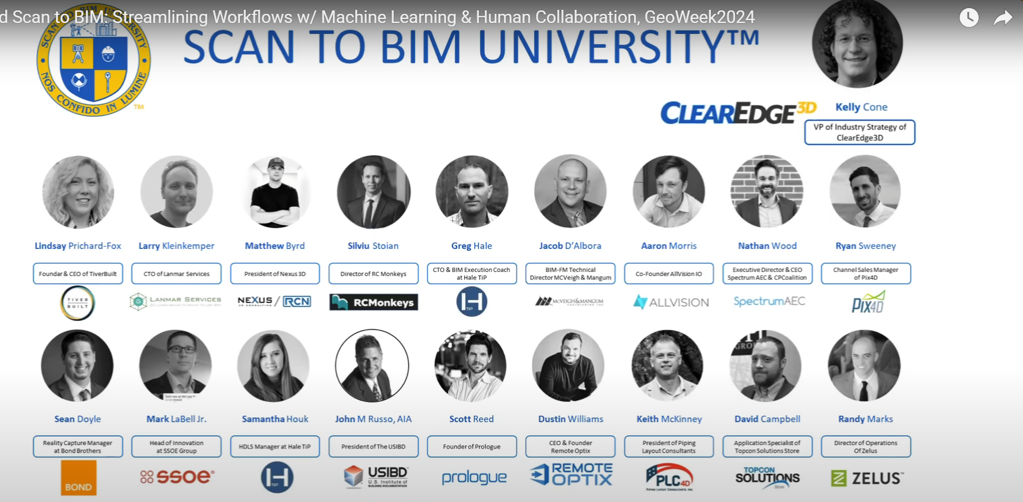

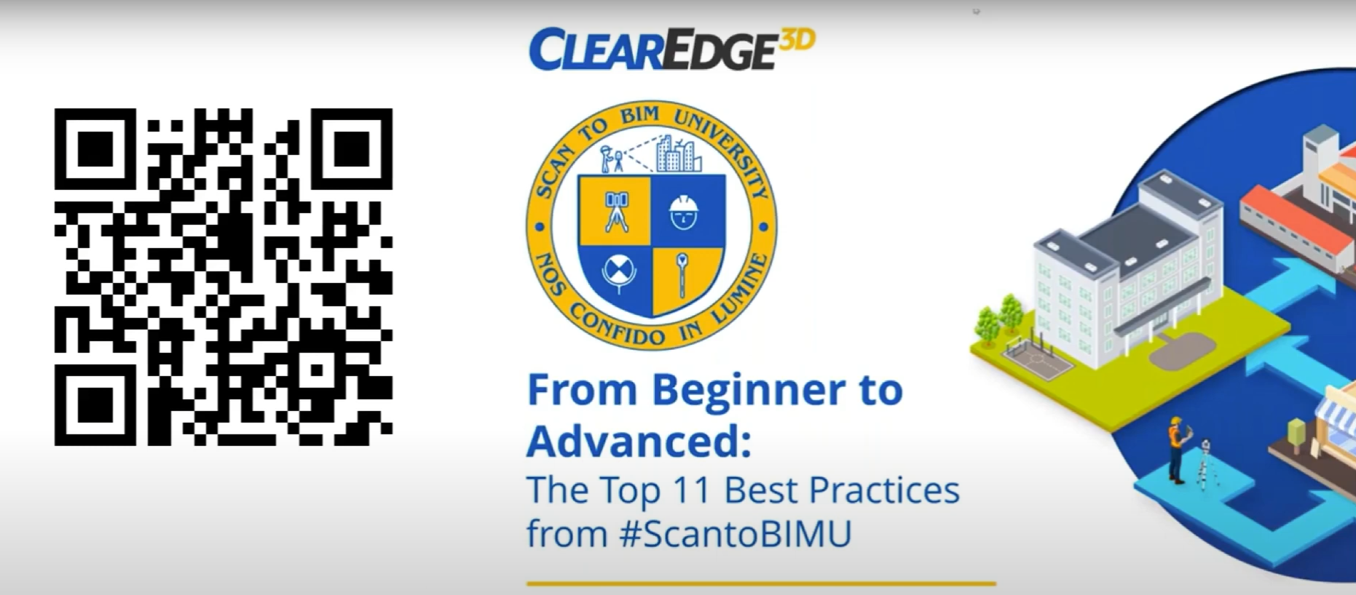

* Ideas for channeling customer:

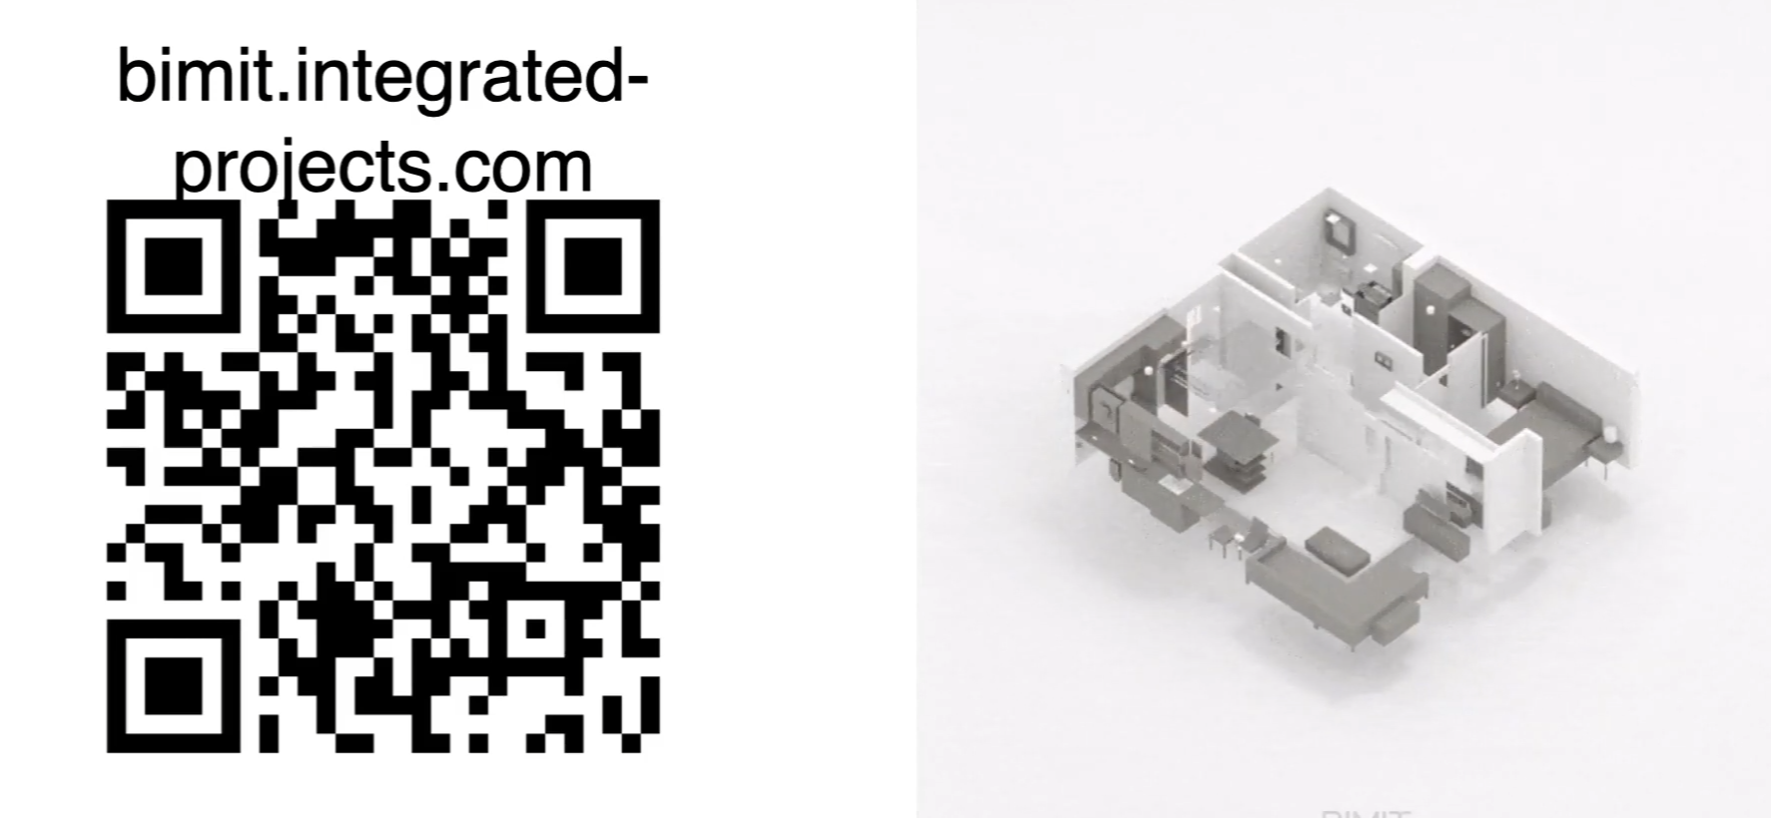

* Tools  
  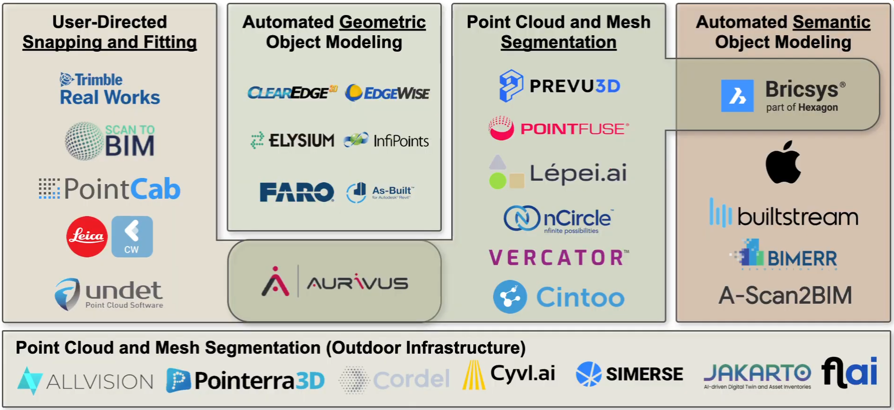

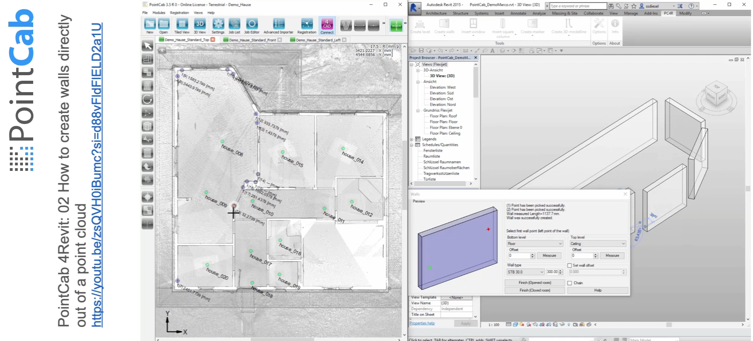

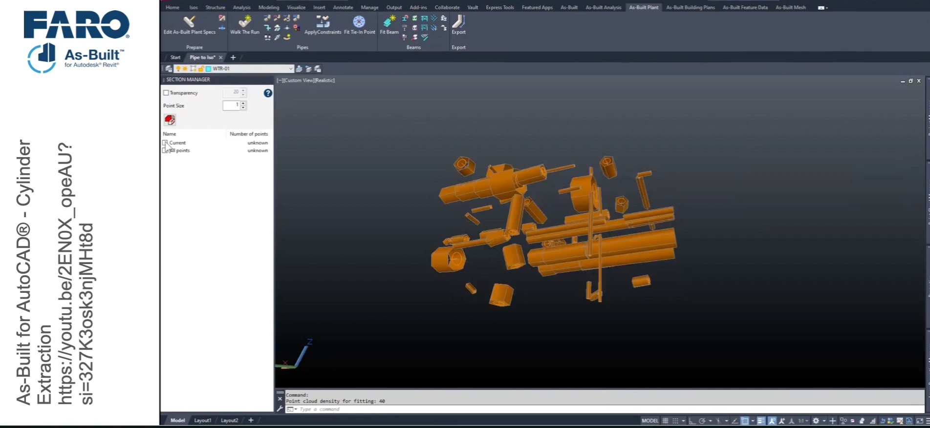

Machine Learning:  
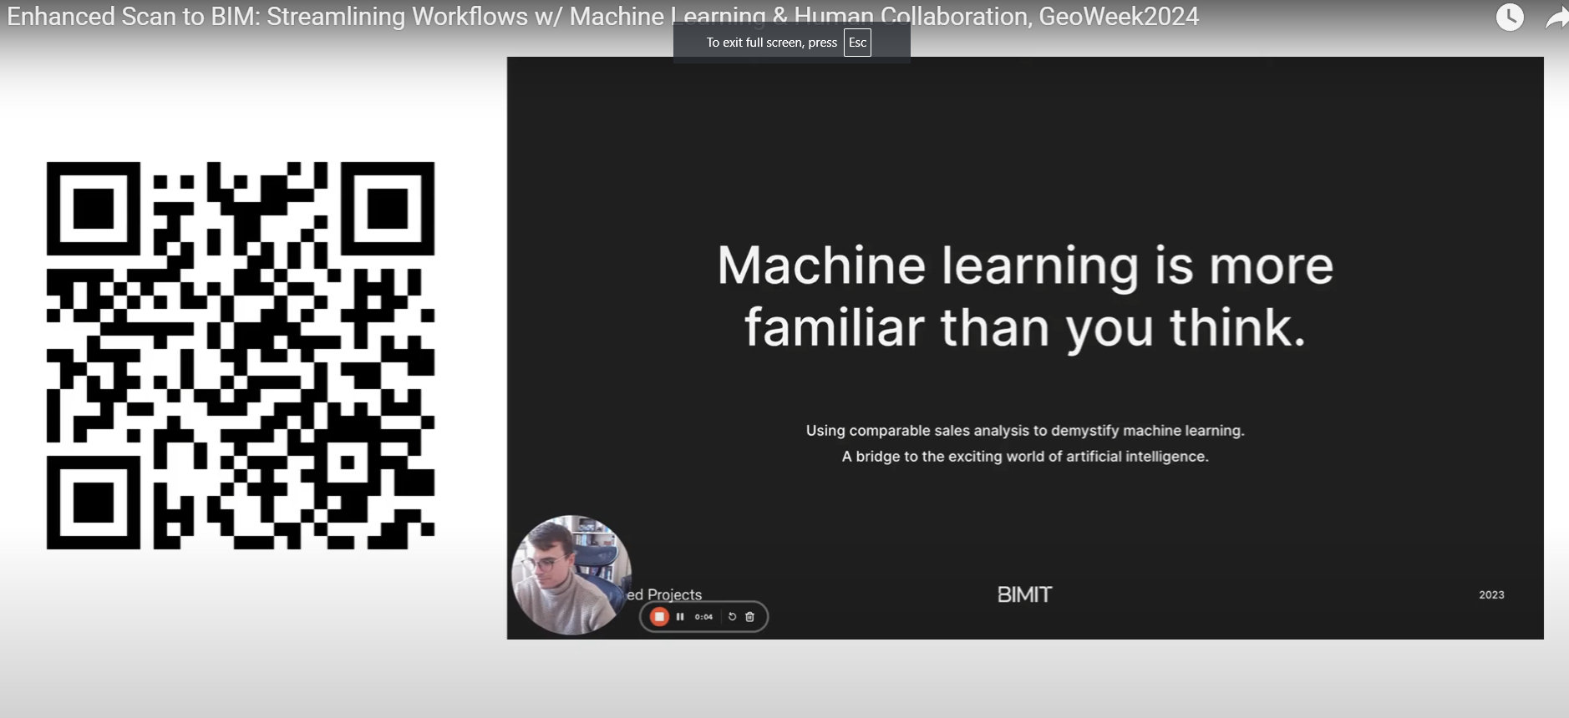

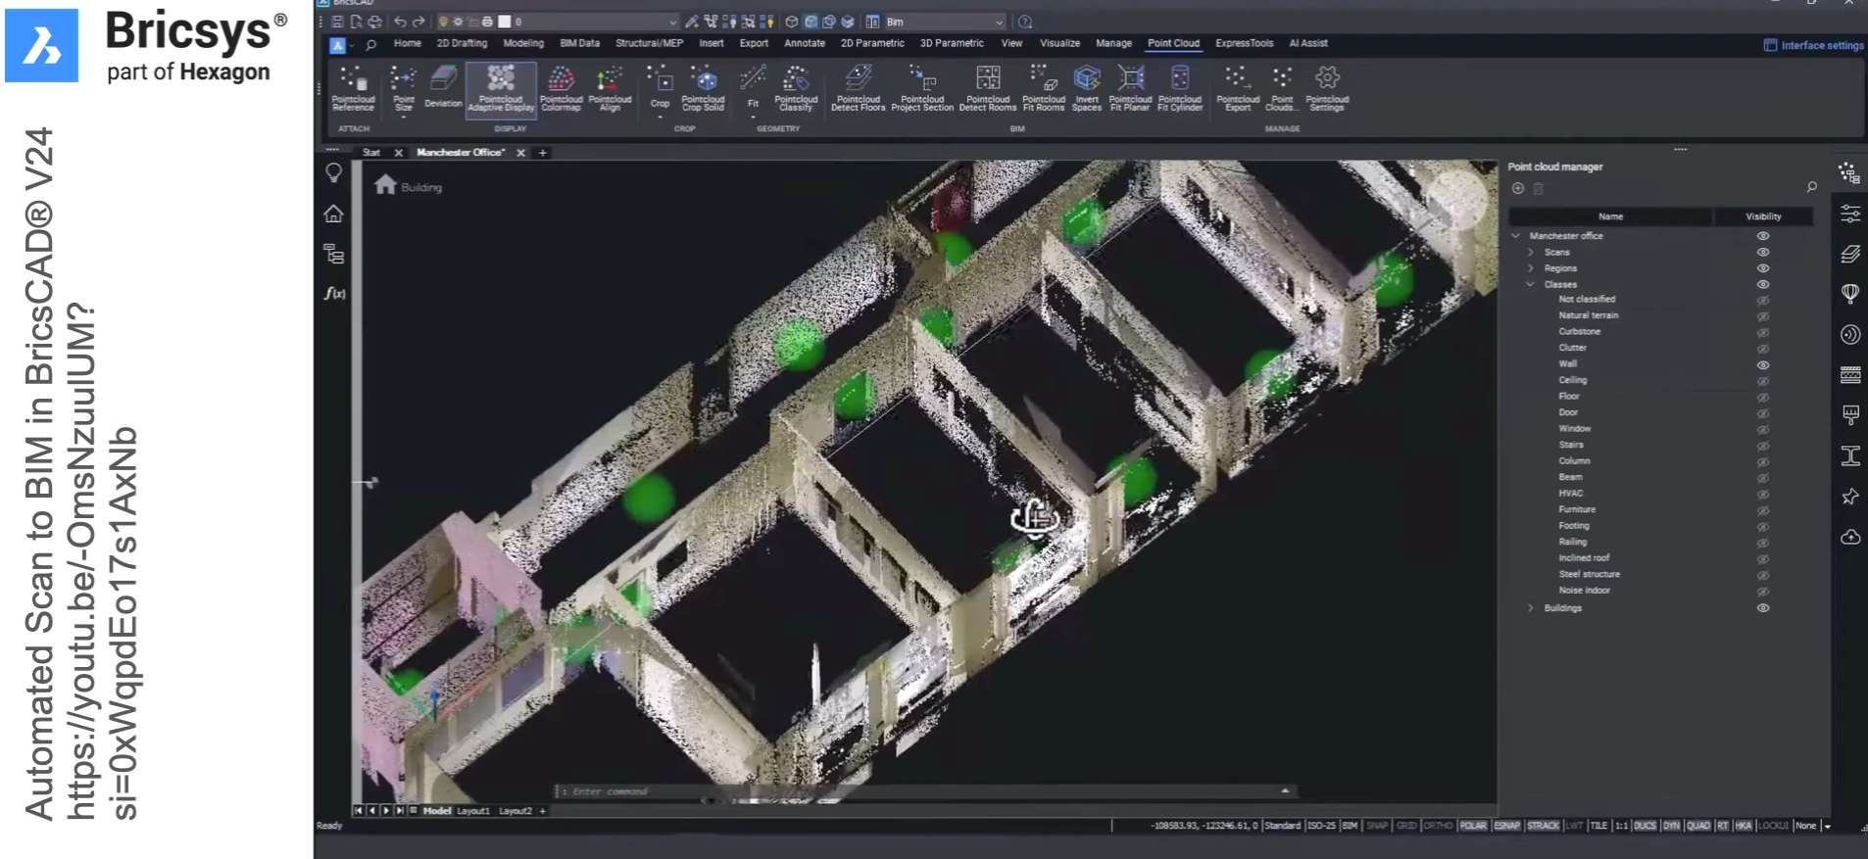

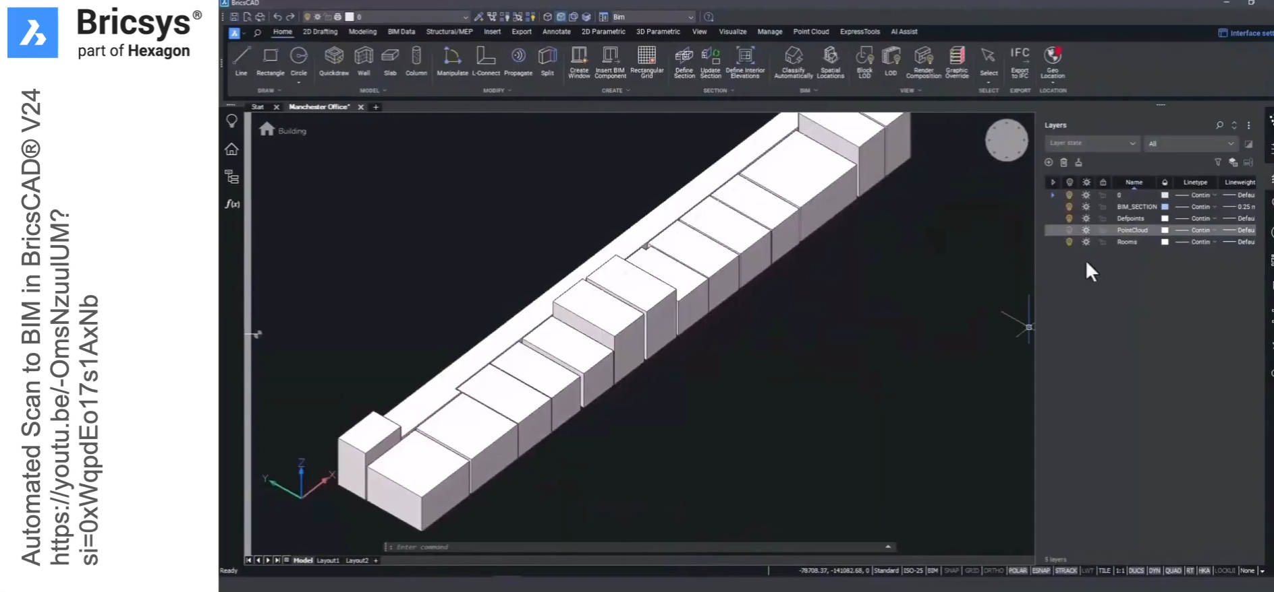

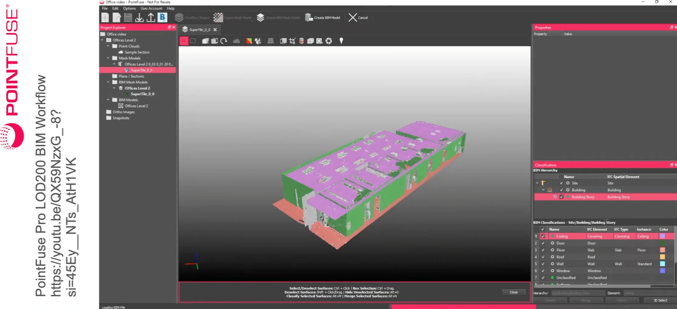

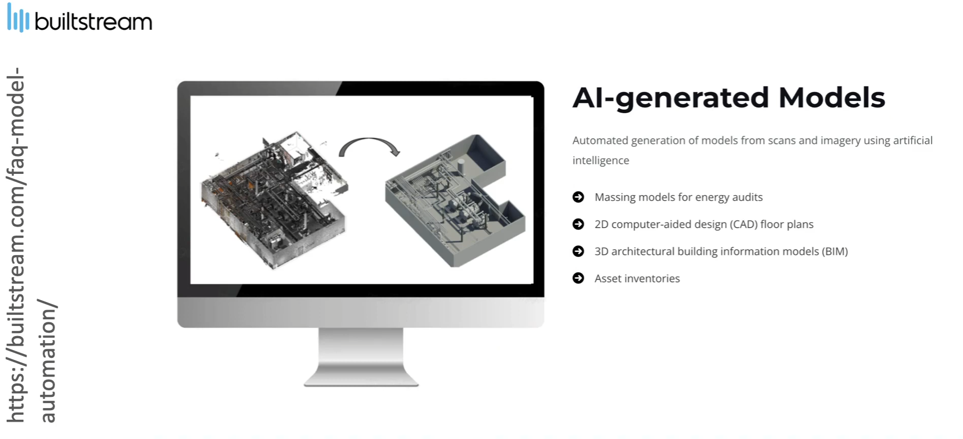

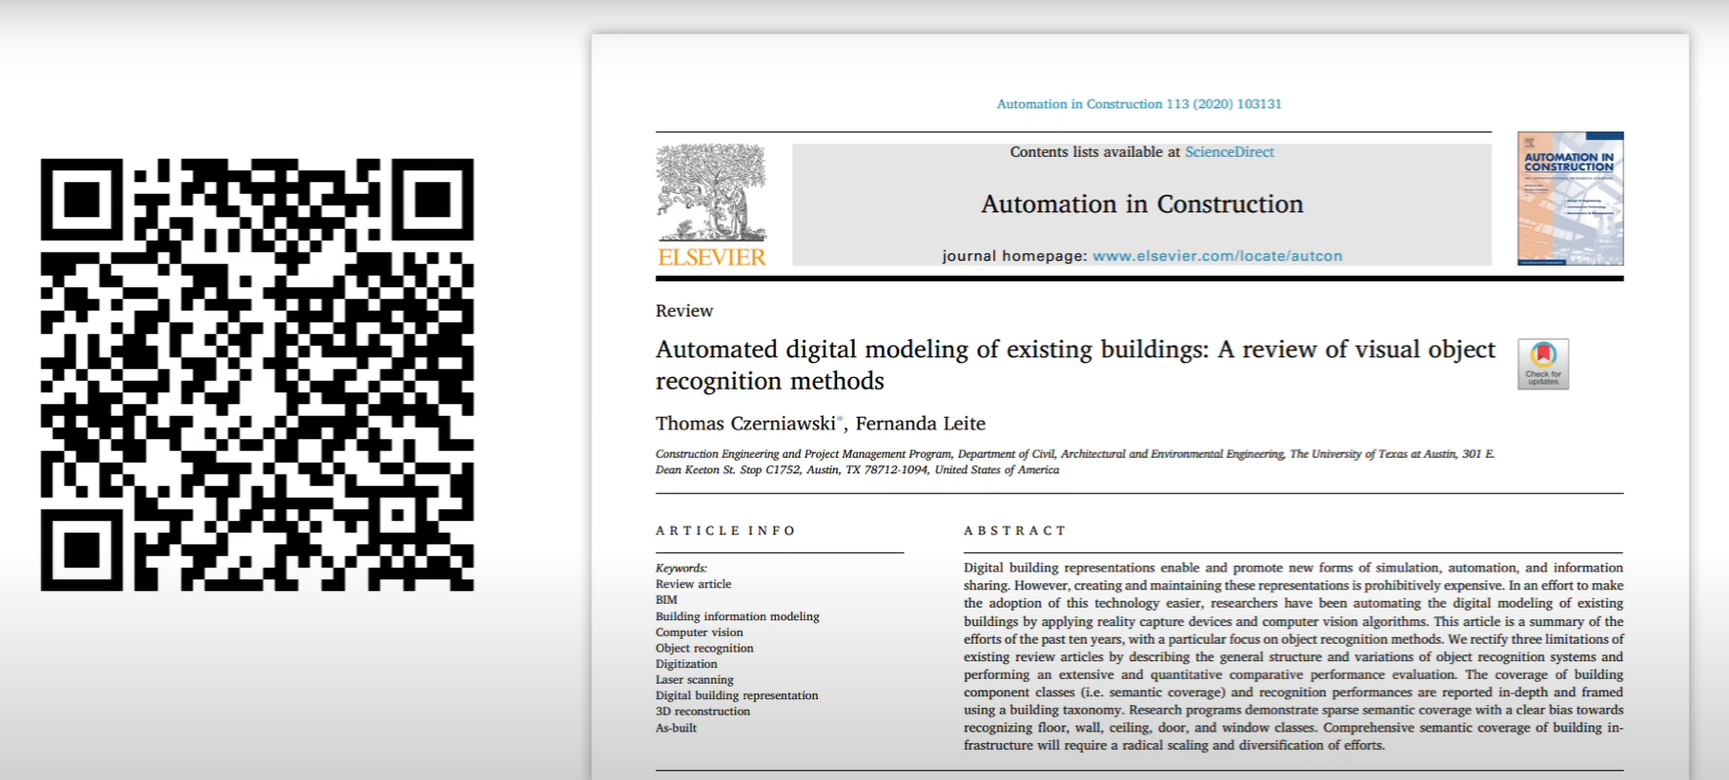

**Action items**